REMOTE LAB

Practical Exercise

CCTV over IP

V1.0

|  |  |  |  |
| --- | --- | --- | --- |
| Hardware List: | | | |
| IP Camera | Compro IP90 |  |  |
|  |  |  |  |
|  |  |  |  |
|  |  |  |  |
|  |  |  |  |
| Software List: | | | |
| Protocol Analyzer | Wireshark | Version | Latest |
|  |  |  |  |
| Remote Lab PC: | RL8 | Remote Lab Type: | A |

RRRemote Lab Type: A-EIT PC with hardware, B-EIT PC with Simulation Software, C-Cloud PC with software, D-Student/Home PC

|  |  |  |  |
| --- | --- | --- | --- |
| Created By: | Deon | Date: | 16/03/14 |
| Checked By: |  | Date: |  |
| Released on: |  | Next Review Date: |  |



1. **Objective**

The objective of this exercise is to observe the network traffic generated by a ‘CCTV over IP’ security camera.

Log in to Remote Lab X to access the camera.

1. **Background**

The IP90 is a (now superseded) security camera manufactured by Compro.

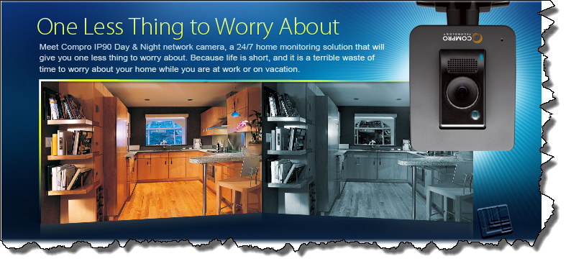

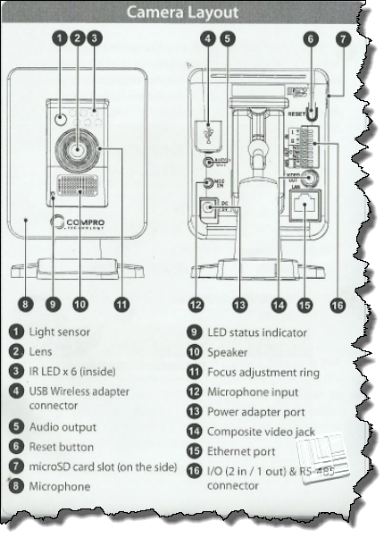

For more detail refer to <http://www.comprousa.com/en/surveillance/product/ip90/>

The camera is already set up in the EIT Remote Lab area, but for an overview of the setup procedure you may refer to Annexure A.

The lab setup is as follows.

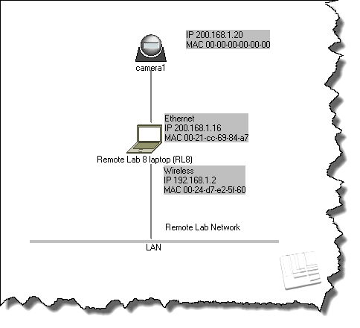

The IP90 uses RTSP. For more on this protocol, refer to <http://goo.gl/Y8he> and <http://goo.gl/Y8he>.

Most articles on RTSP point out that RTSP provides control, and the actual data is transported by the Real Time Protocol (RTP). However, the IP90 camera interleaves the data as RTSP packets.

1. **Instructions**

**3.1 Logging in**

Log into Remote Lab 8.

**3.1 Checking that the camera is operational**

Before you continue, ensure that the camera is present on the network. From the Command Prompt, ping the camera (**ping 192.168.1.8**) and confirm that you get a response.

Now run Internet Explorer and type in the IP address of the camera.

In theory you should type **192.168.1.8:80** in order to access the webserver interface on the camera, but your browser will default to port 80 anyway.

The following will open up, and you should be able to observe the object that the camera is pointed at.

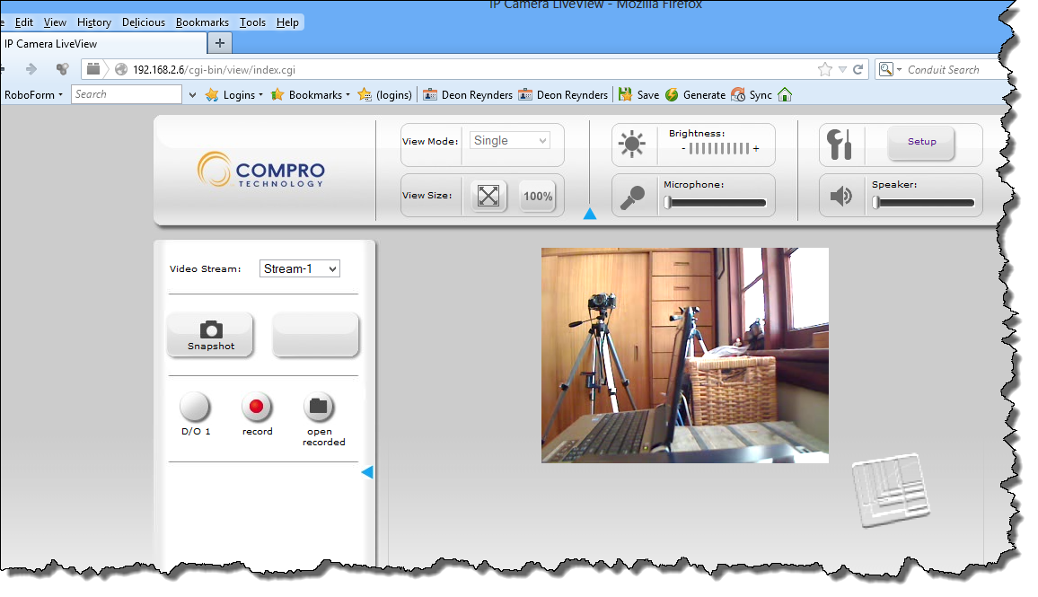

If you are challenged for a username/password, you can type in ‘admin’ and ‘idc123’.

* 1. **Capturing camera traffic**

Run Wireshark

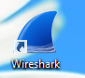

Select *Capture->Interfaces*, select ‘Ethernet’ and then click ‘Start’.

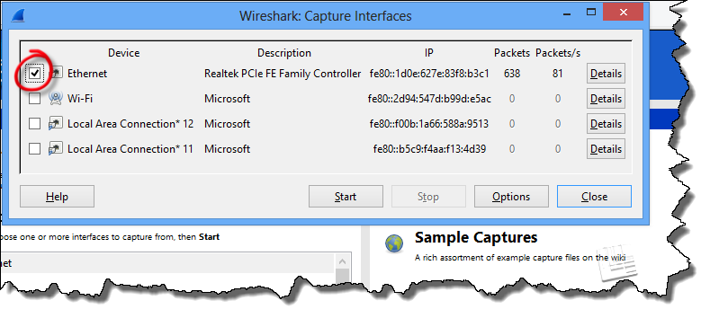

Now enter ‘rtp’ as a filter, and click ‘Apply’.

Capture for a few seconds, and the stop. You will notice that most (if not all) packets are emanating from the camera.

Choose one of the data packets sent by the camera. Select one of the ‘Interleaved channel’ packets (see red arrow below) and confirm the IP addresses for the packet (both camera and Remote Lab computer).

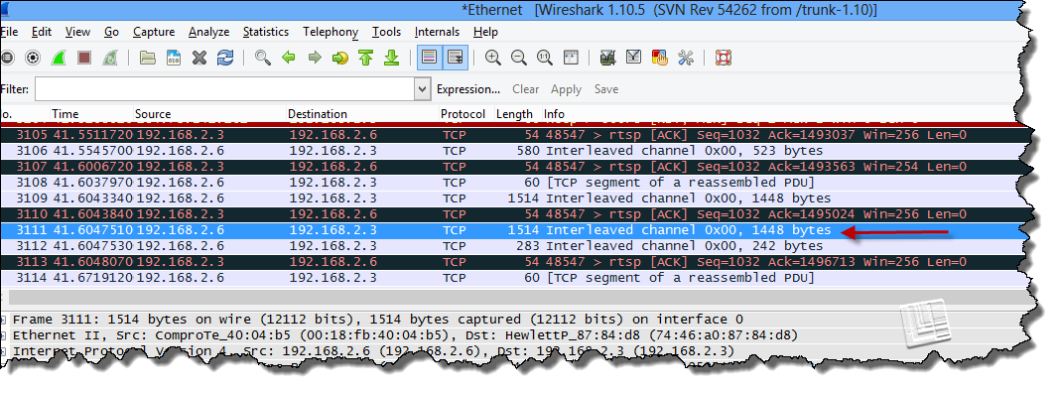

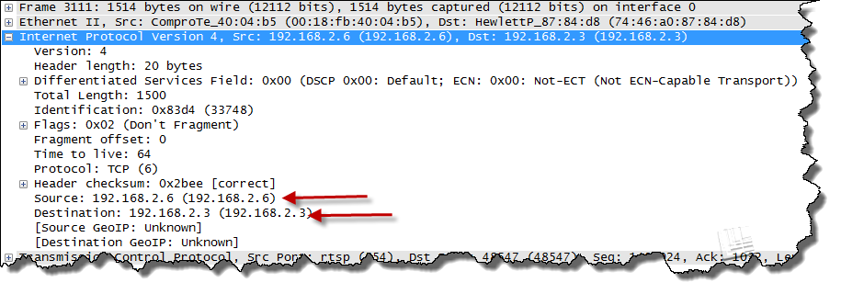

Open up the TCP header, and note the (source) port on the camera side. The port number (554) is allocated to the Real Time Streaming Protocol (RTSP).

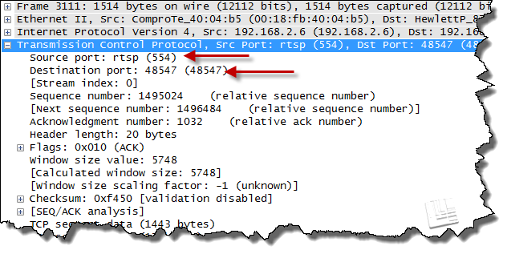

Now open up the RTSP header.

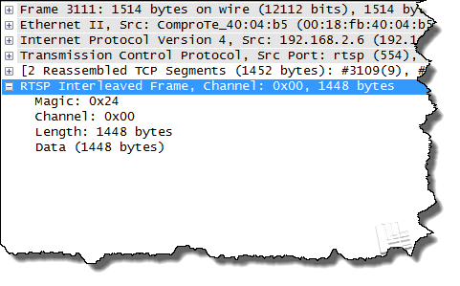

If you look at the upper window in Wireshark you will see the continuous stream of data from the camera, carried by RTSP over TCP and IP.

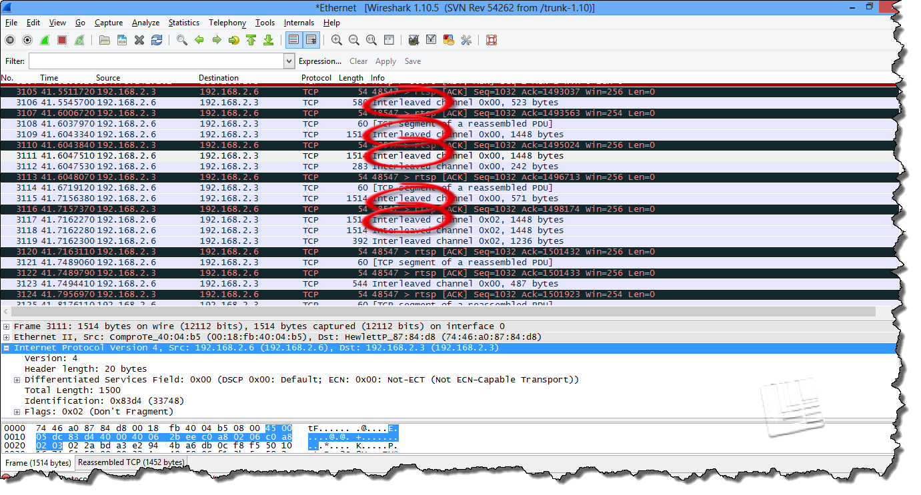

That’s about it!

**END OF EXERCISE**