- THE MAIN GOAL OF SAFETY CIRCUITS:

- To maintain the Water level always 1/3 to 2/3 sensors through PLC-Raspberry Code-Sys Code.
- To Cut-Off the Safety Relay when the level of water goes beyond higher level sensor.
- To Isolate the connection between the conversion relay and Safety Relay once there is trigger in PLC switches.
- To Use Raspberry-Pi microcontroller as a cheap PLC through CodeSys software.
- To add Visualization/SCADA through Code-sys and controlling it through two-way communication.

- DEVICES USED:

POWER SUPPLY: It is a normal power supply NET-50D with 3 output voltages +5v, +12v, +24v.
CONVERSION RELAYS: This Funduino-0932640012 conversion relays with 4 SPDT consumes +24 volt and it receives signal from Raspberry-Pi GPIO and triggers the relays to control another relays or components. During the operation 2-relays are used to ON/OFF motor pump and drain solenoid through PLC 1/3 level and 2/3 and remaining 2-relays to cutoff motor pump and drain solenoid with each other in smart way plus High-Level.
SAFETY RELAYS: This safety relays HF10FF is DPDT-relay which operates in +24v and one pole is used control water pump or drain solenoid valve and another pole to detach from the +24v which is controlled through one of the conversion relays.
DRAIN SOLENOID: It is normally used to flow water from upward container to downward container and this drain solenoid needs +12v although the flow of water is slow.
WATER PUMP: This water pump need +12v and it has both inlet and outlet.
LEVEL SENSORS: These are the normal reed switch and when it is closed it is short circuited, taken as (1) and when reed switch is open then it is taken as (0).

RASPBERRY-PI 3B+: It consumes +5v and its GPIO-PLC outputs are used for controlling the peripheral components such as motor, solenoid valve and also to receive PLC command. It is the 1.4GHz 64-bit quad-core processor, dual-band wireless LAN, Bluetooth 4.2/BLE, faster Ethernet, and Power-over-Ethernet support (with separate PoE HAT).

- Outlook of Safety Circuits:

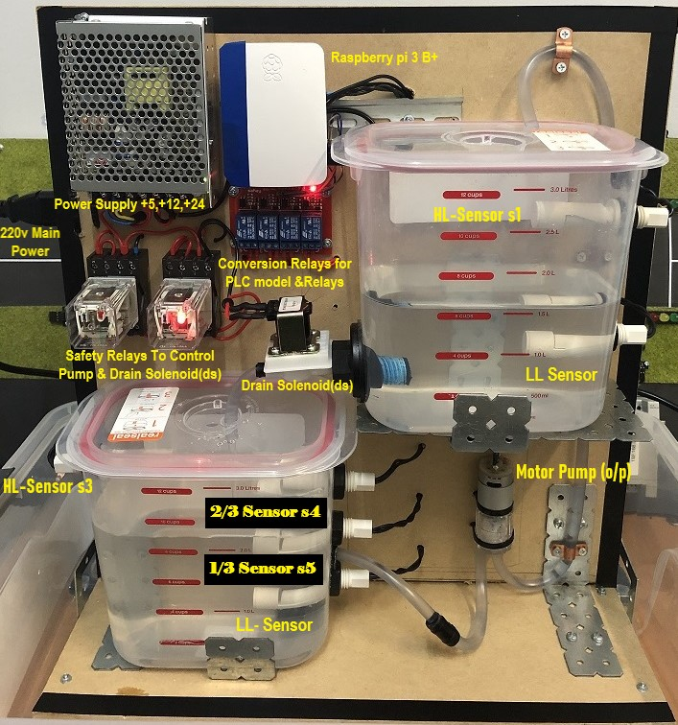
Note: Always power off the Safety Relay Circuit with both levels 1/3 & 2/3 either high or low.

- Diagram of Safety Circuits:
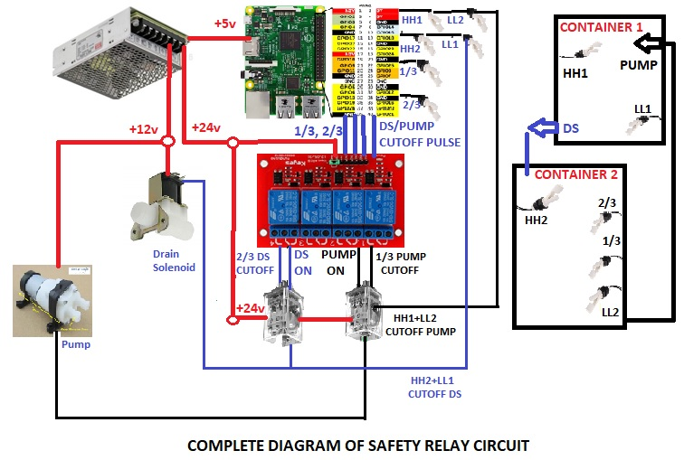

To Control these mechanisms, we used 6 GPIO pins from the Raspberry where 4 pins are used as input level sensors and 2 outputs for drain solenoid and water pump motor through conversion and safety relays where for cutoff, ‘ON’ pulses of pump and DS are used each other.

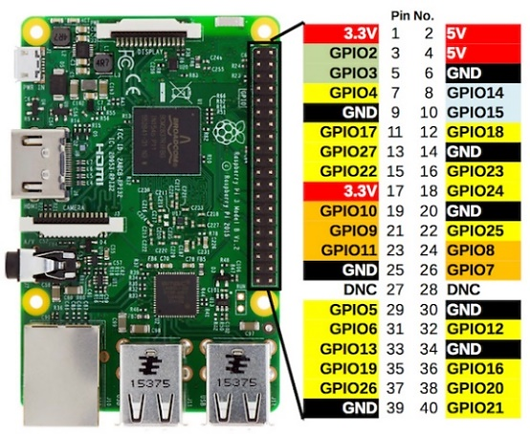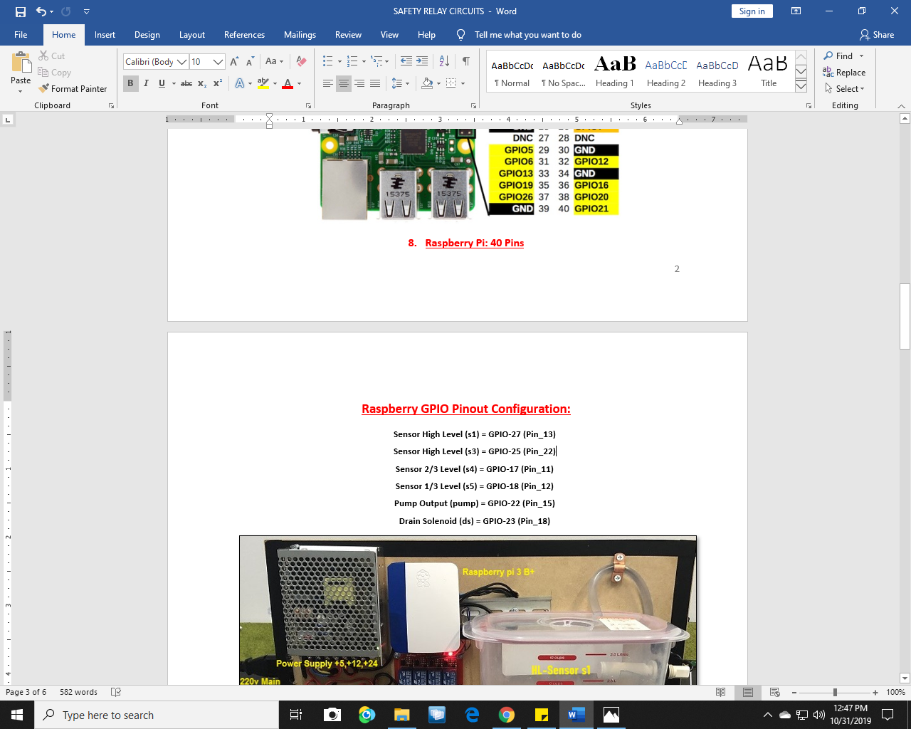
- Programming Raspberry-Pi

https://www.raspberrypi.org/products/raspberry-pi-3-model-b-plus/

https://www.raspberrypi.org/downloads/raspberry-pi-desktop/

Click link and download full ‘NOOBS’ version of operating system of Raspberry-Pi in SD card to boot Raspberry-Pi through HDMI plug.

After booting Raspberry Pi Login to Raspberry-Pi and enable ‘SSH’ Secure Shell to enable to control from GPIO pins to the conversion relays.

Enable SSH
Raspbian has SSH server disabled by default. Enable manually from the desktop:
- Launch Raspberry Pi Configuration from the Preferences menu
- Navigate to the Interfaces tab
- Select Enabled next to SSH, Click OK
Alternatively, raspi-config can be used in the terminal:
- Enter sudo raspi-config in a terminal window
- Select Interfacing Options
- Navigate to and select SSH
- Choose Yes& select ok& Choose Finish

OR Open Raspberry OS in screen and follow given visual instruction.

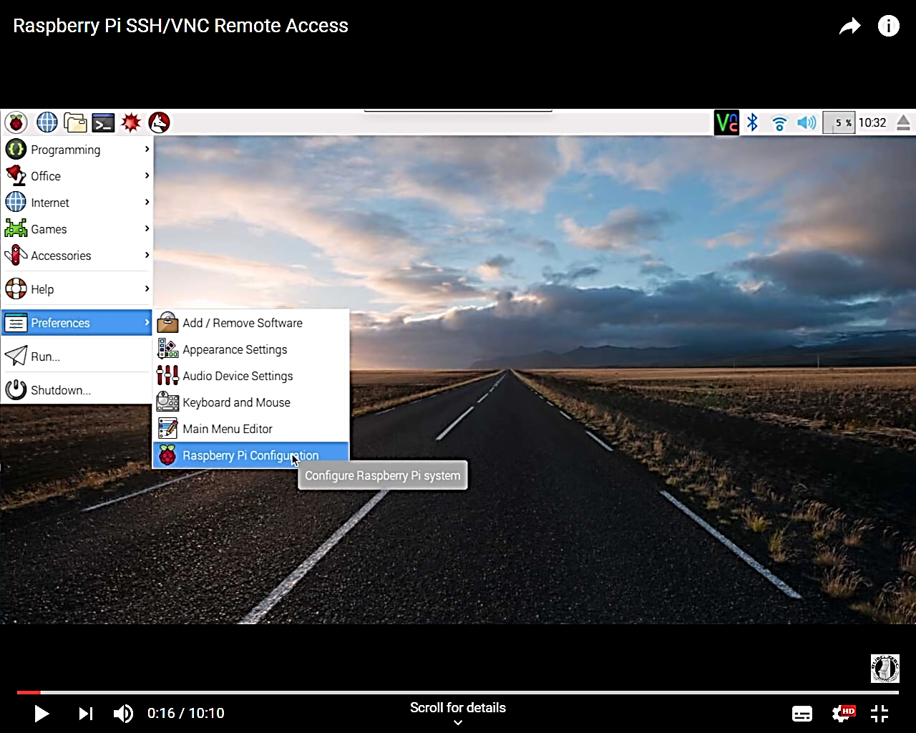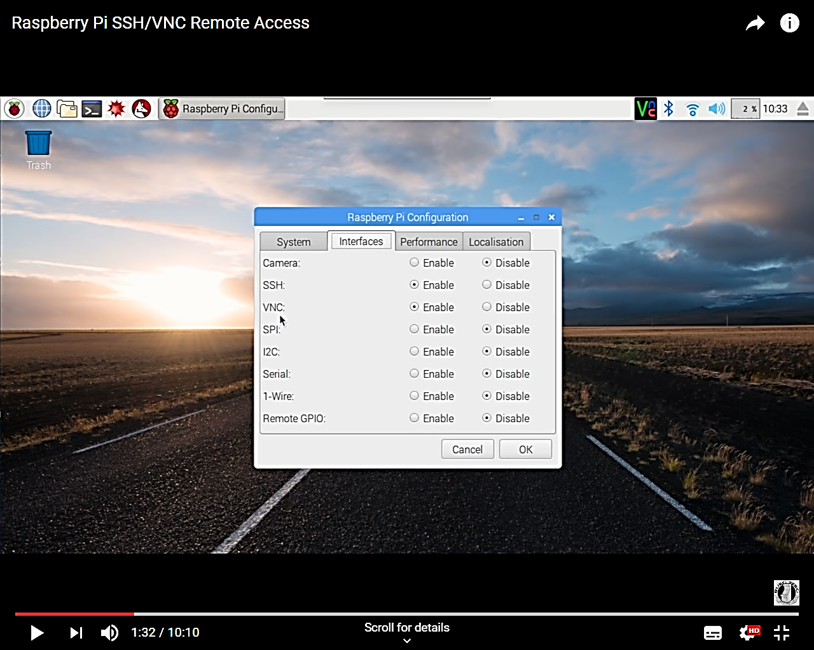

10. Enable all functions from the Interface to control GPIO pins.

    - Codesys Software and Ethernet
First of all download Codesys and ‘’Raspberry control from Codesys Pi SL’’ from https://store.codesys.com/codesys-control-for-raspberry-pi-sl.html?___store=en The trail version also can be downloaded but it works for only 2 hours and you have to start again.

Start Codesys and ‘’go tools---package manager’’ and install the above driver.
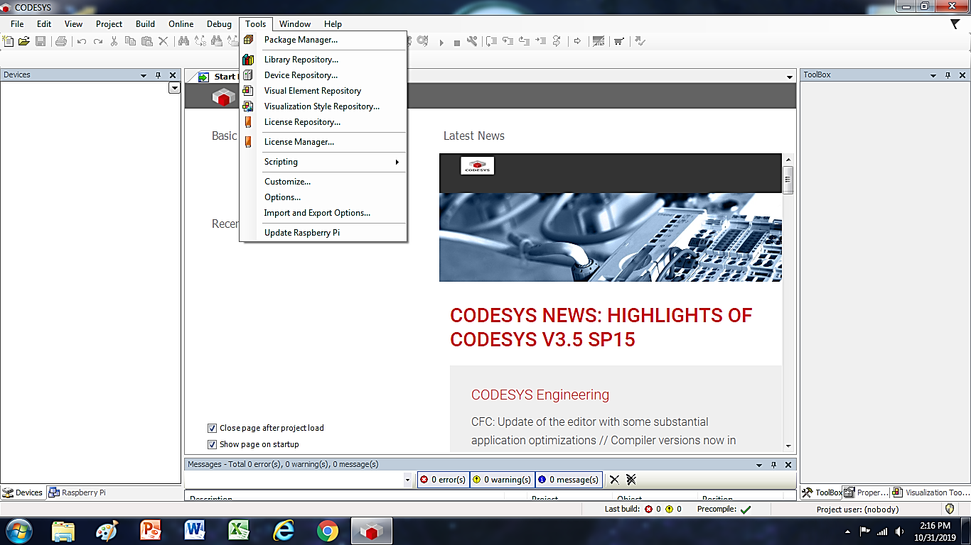
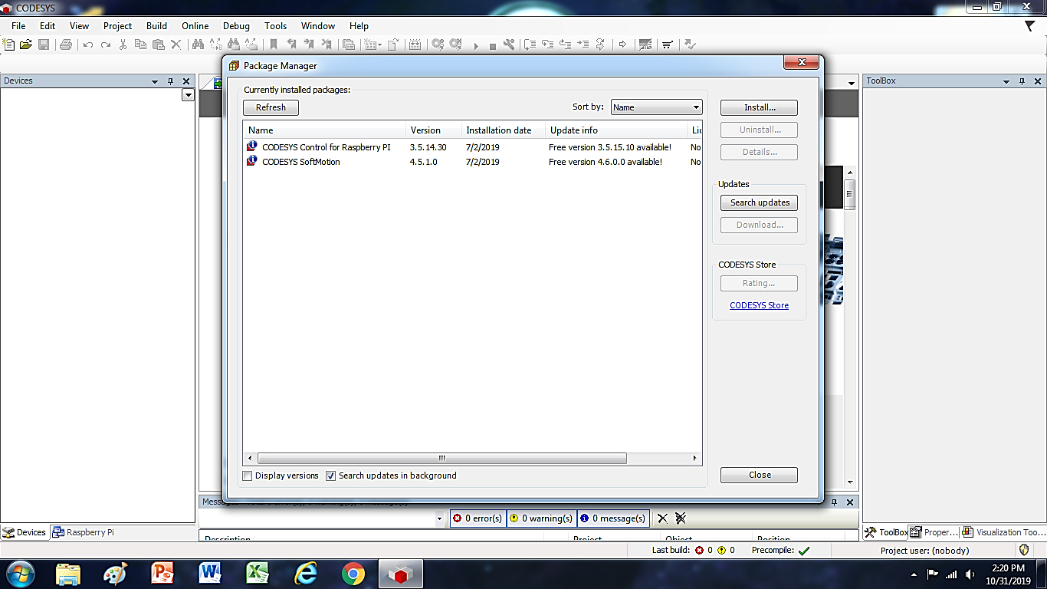
Go to the ‘’Update Raspberry Pi’’ and new screen will pop out where type the password’ ’Raspberry’’ and Scan continuously to find IP Address of the ethernet.
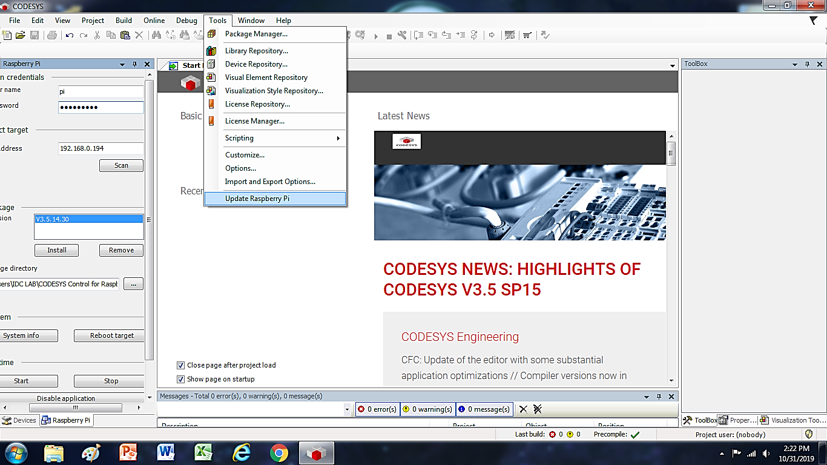
Programming in Ladder Language in Codesys merged with Raspberry Device.

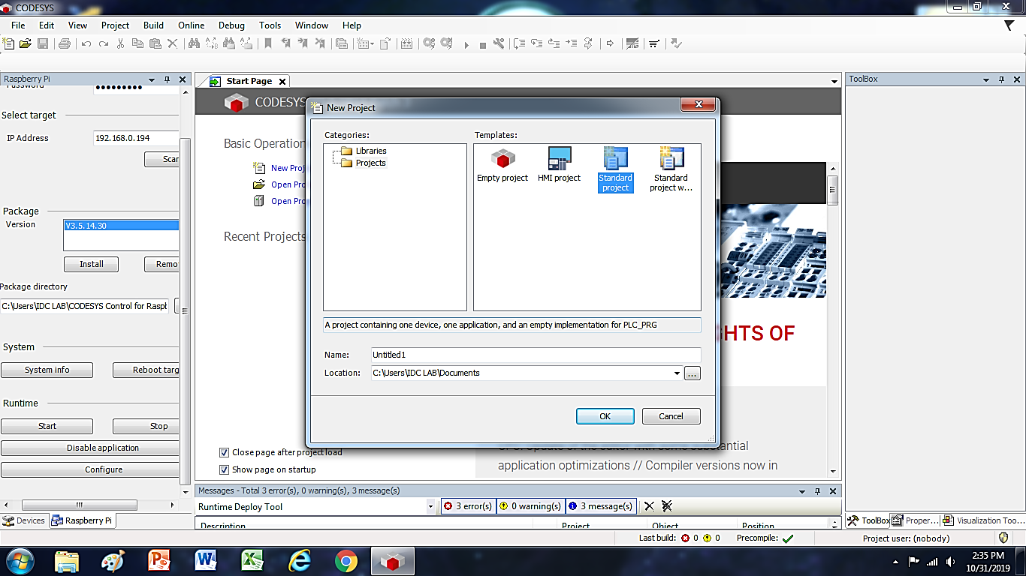

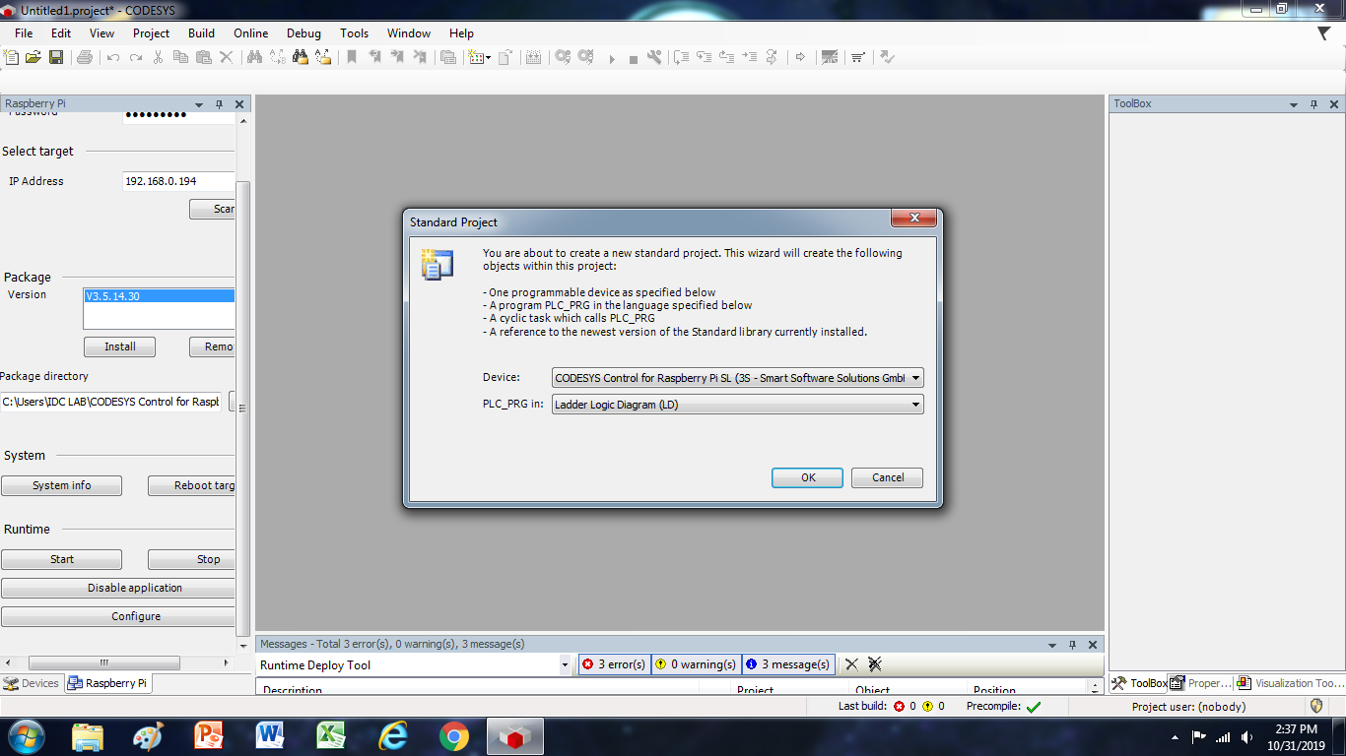

Once the Codesys opened you can see this screen will pop-out in the lower side with name ‘’Devices’’ where in the ‘’Application’’ you can code in ‘’PLC_PRG’’. Code is Given.

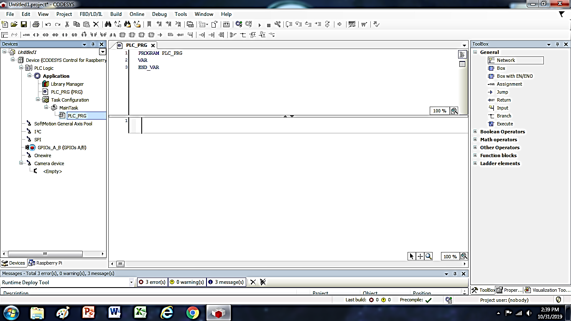
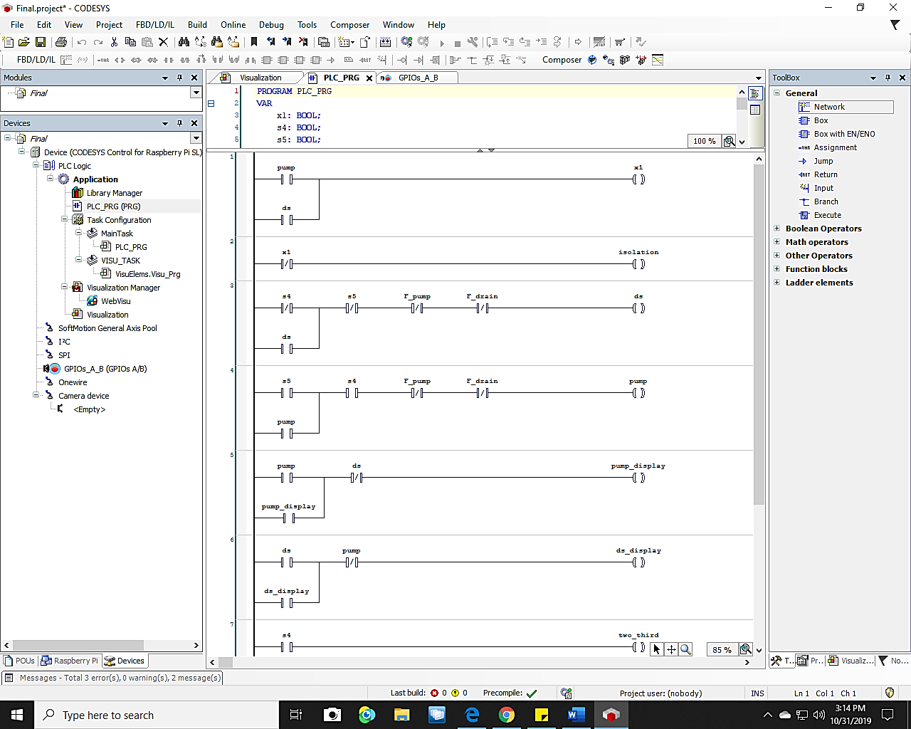
GPIO_A_B is the place where we have to assigned our input/output values to control 6 pins of Raspberry. First Declare the input and output in ‘’GPIO I/O Parameters’’ and then assigned the variable in ‘’GPIO Mapping’’.

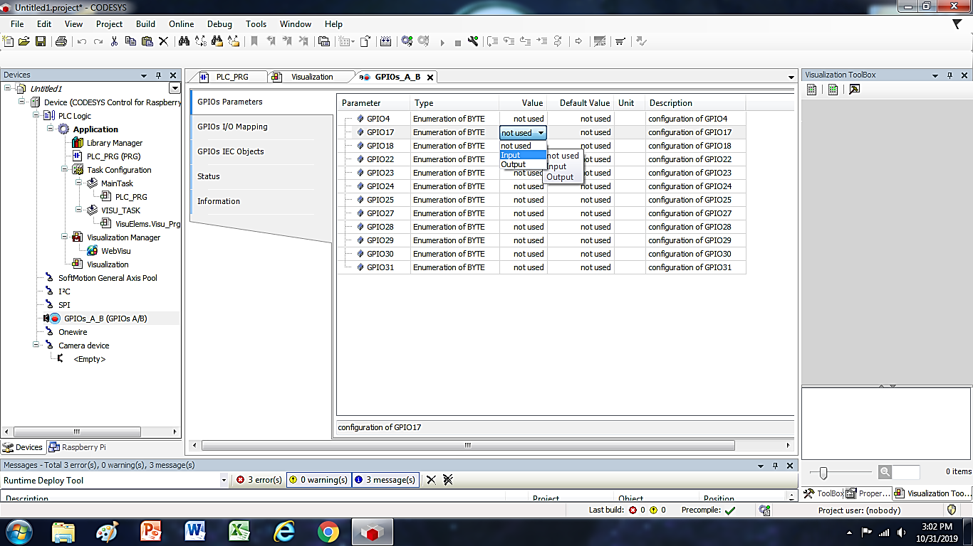

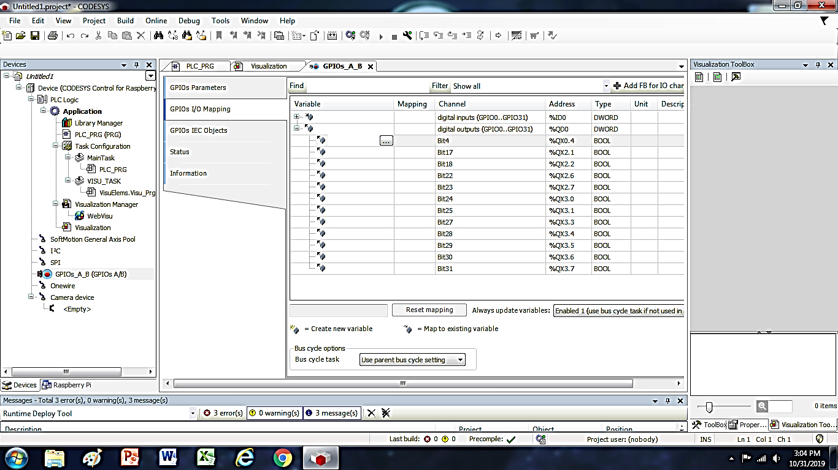

For the SCADA go to the ‘’Application’’ and right click than ‘’Add Object’’ and Click ‘’Visualization’’ than drag different variables to make the visual interface.

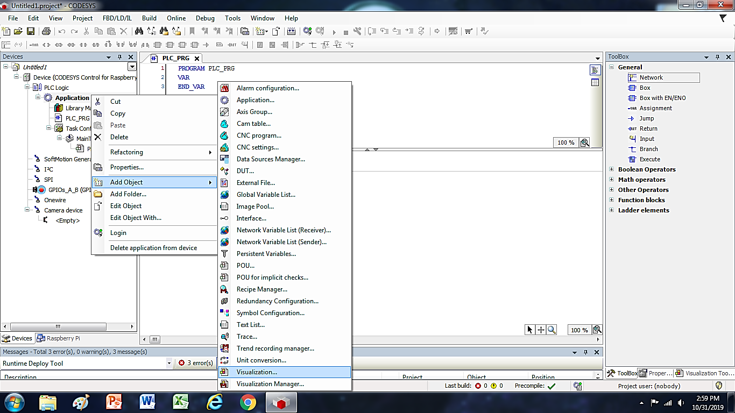
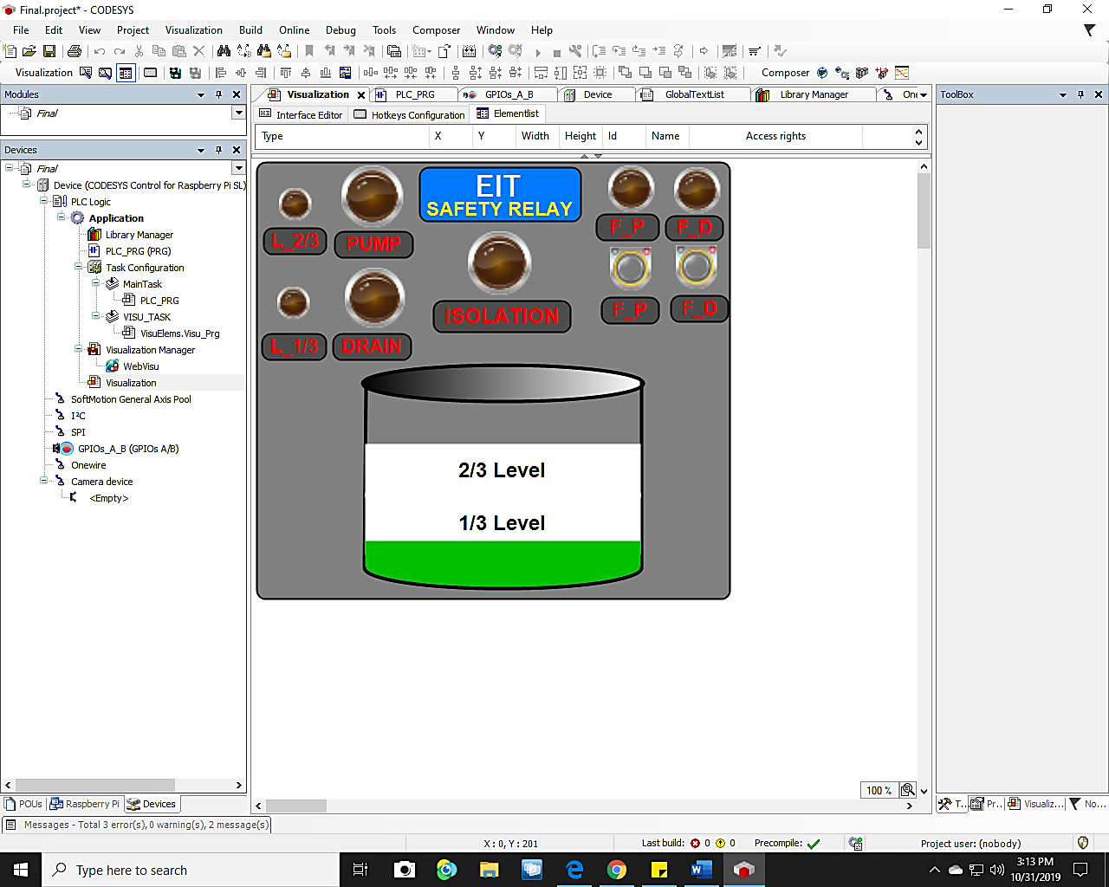

To Visualize in the webpage simply we have to use as shown in figure ‘’WebVisu’’ under ‘’Visualization Manager’’ and see it and control through different computer, laptop, mobile or iPad in given address. The I.P link varies because Raspberry-Pi has default dynamic i.p address.

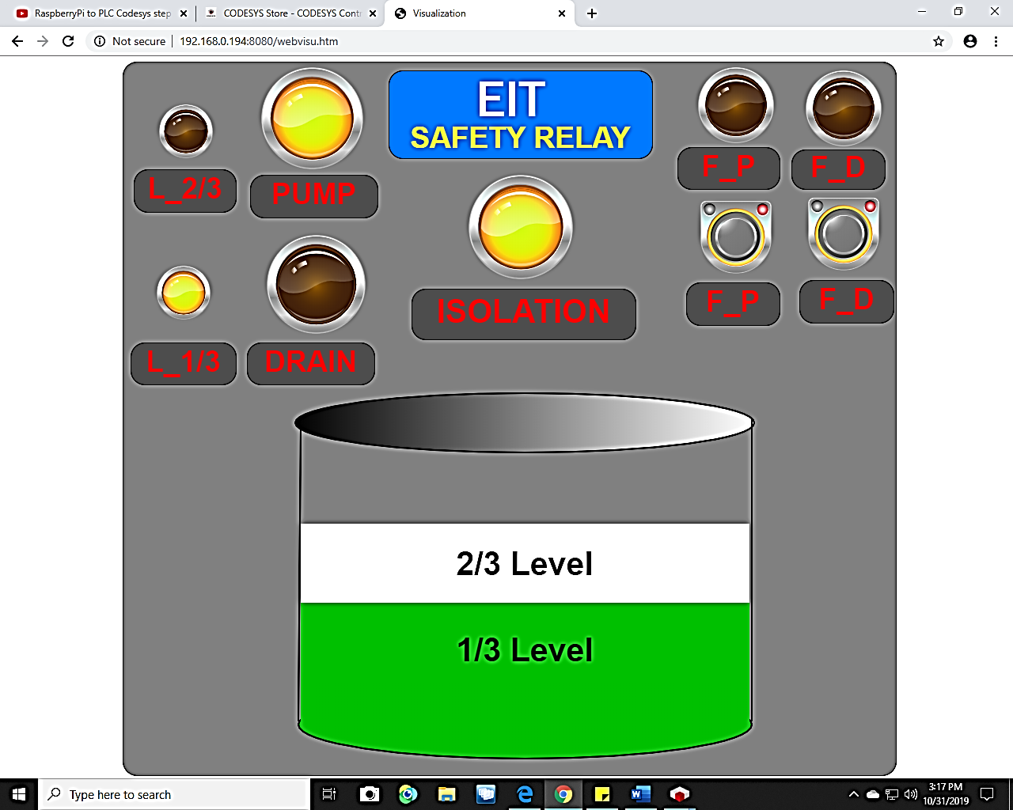
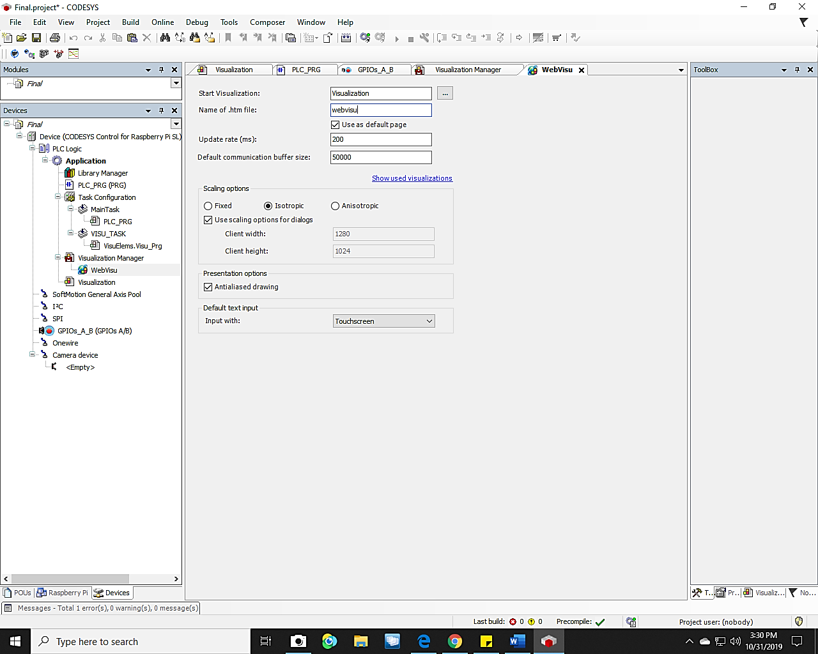
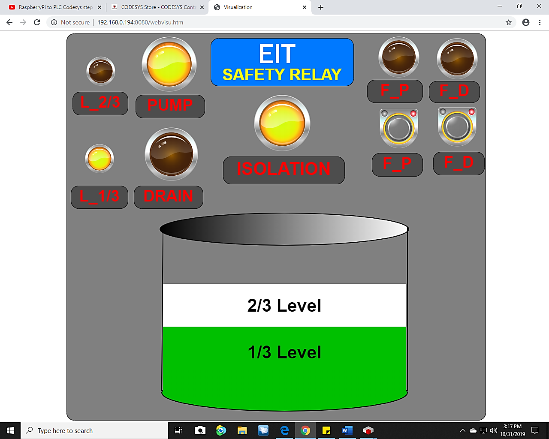

Thanks

