**Setting up the DNP3 Slave Emulator for student testing.**

Login to DNP3 Remote Lab.

Open xMaster under: Start->All programs->xMasterSlave->xMaster



Click DNP Slave

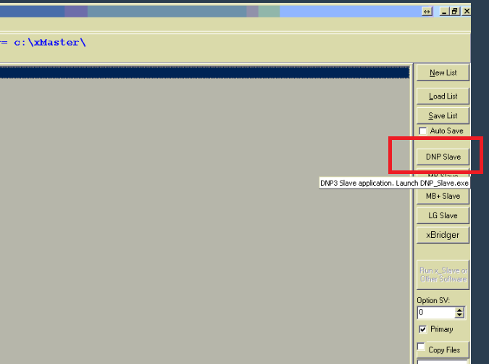

In DNP Slave window, enter the “CheckAddr” to **1**

And click the “Slave: STOP” green button to switch on the slave emulator. The button will turn red and state “Slave: RUNNING”

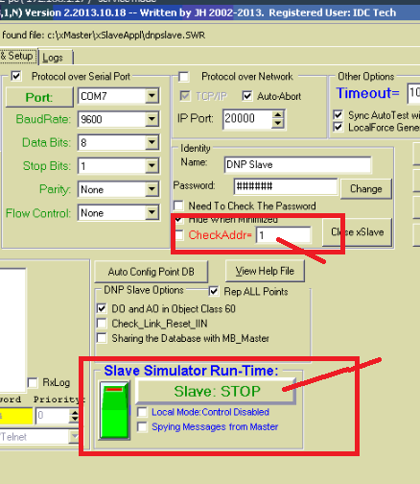

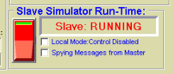

Then in the xMaster window, click the “Run x_Master” button, and wait for the system to configure everything.

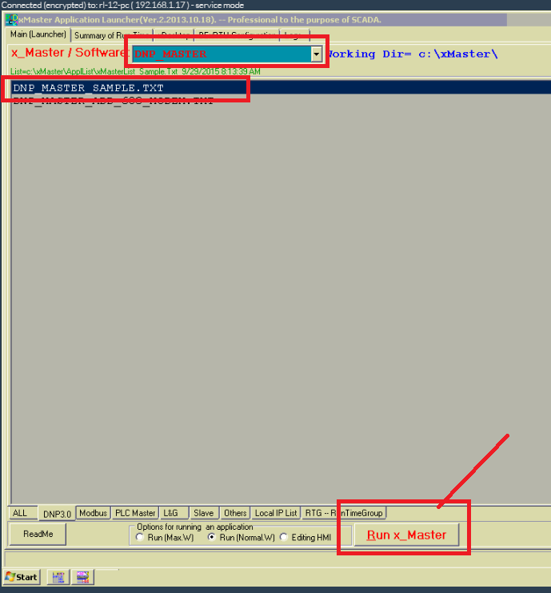

Once done, minimise everything, (Don’t close, as the emulator will then stop).

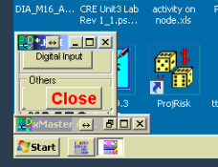

You can test the settings using the “Configurator” program (on the desktop), opening the “DNP3Slave.rtu”, and for Target DNP3 address 1, running “transfer - > Class 0 poll” for address 1.

You should get a success message.

