Fundamentals of

Professional Engineering

(FPE)

GanttProject Tutorial

V1.4

***ODEL ANSWER***

.



**…**

**Preparation**

Download and install [GanttProject](http://ganttproject.biz). You can also get it [here](http://eitdata.info/fpe/FPE_Software_GanttProject_Setup.exe).

In this example we will only create a schedule, and we will not address the resource issues although resource creation and allocation with GanttProject is extremely simple.

For more help, Google ‘ganttproject tutorial’.

**Problem**

There are three tasks (X, Y, Z) with durations as follows:

X: 10 days

Y: 5 days

Z: 20 days

Y can start when X is finished

X and Z can start immediately

The work is finished when Y and Z are done.

**Solution**

You have to create two (zero duration) milestones viz. Start and Finish.

Run GanttProject and create a new project (Project->New). For now, just accept the default values.

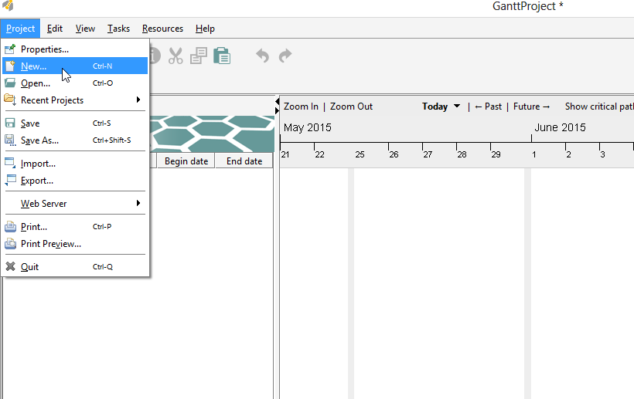

Add a new task (Tasks->New Task)

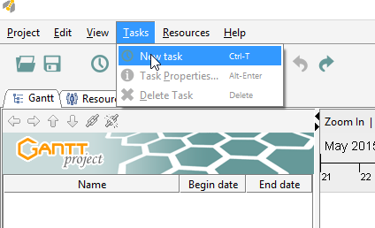

A new task will be created. Edit the name to read ‘Start’.

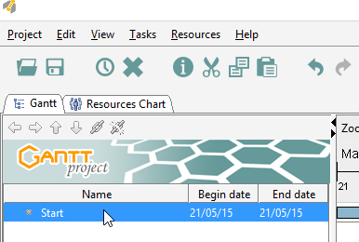

Click Tasks->Properties and check the box to make it a milestone.

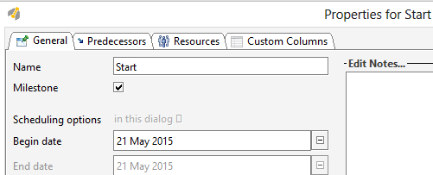

Now add another task (Tasks->New Task) and call it X. You can also get to the task creation menu with a right-click.

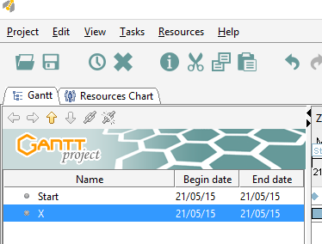

Make sure it is highlighted, then click Tasks->Properties. Set the duration = 10 days.

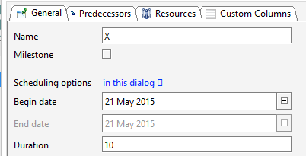

Now select the Predecessors tab, and Add ‘Start’ from the drop-down list (Start is a predecessor to X, remember?).

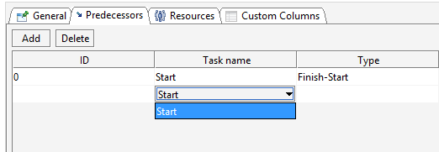

Now do this with Y, Z and Finish, keeping in mind that Finish has more than one predecessor.

You will end up with something like the following. Look at it carefully and confirm that it ‘makes sense’.

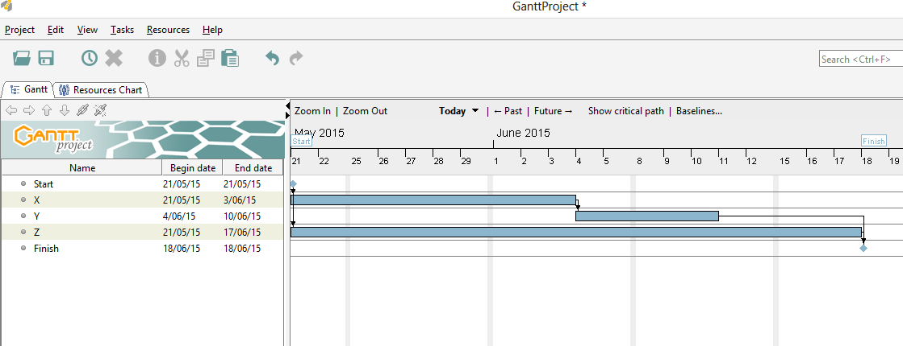

Finally we can View->Pert Chart and get this:

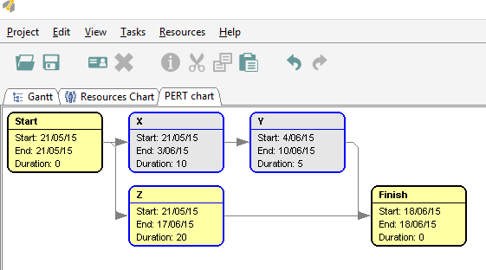

Done!