Fundamentals of

Professional Engineering

(FPE)

ProjRisk Tutorial

V1.4

***ODEL ANSWER***

.



**…**

**Preparation**

Download an evaluation copy of [ProjRisk](http://eitdata.info/fpe/FPE_Software_ProjRisk_Setup.exe).

**Problem**

A project has three tasks viz. Z, Y and Z with associated costs as shown below. Based on past experience, we know that the costs will behave as follows:

X: $10,000 -20%/+20% triangular distribution

Y: $5000 -0%/+15% triangular distribution

Z: $20,000 -5%/+15% triangular distribution

What this means is that, for example, the likely cost of X is $10,000, but that it can be as low as $8,000 and as high as $12,000. In the case of Y the cost could higher, but not lower.

**Solution**

Run ProjRisk.

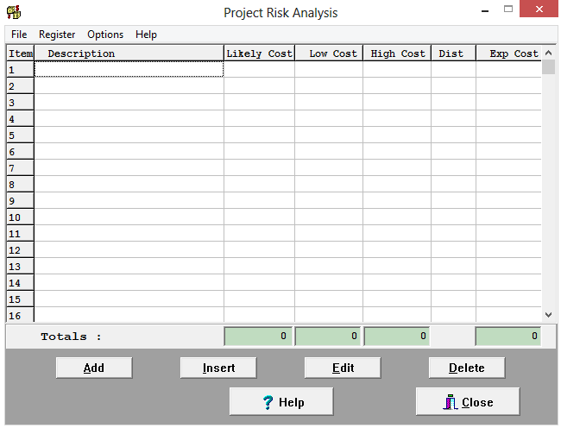

Enter the data for X. Note the absence of $-signs and commas. The high and low values can be entered as numbers or percentages.

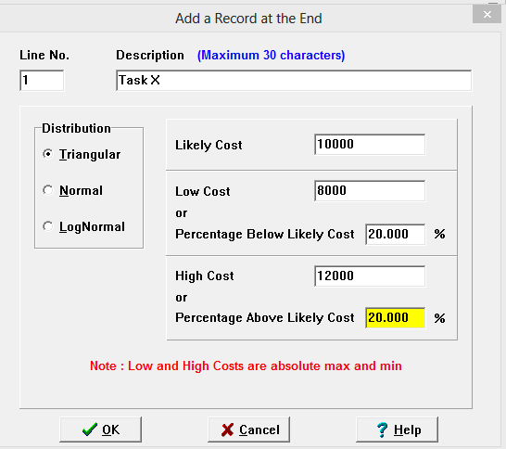

Here is the entry for Y. The software inists that the Low Cost must be lower than the Likely Cost, therefore an amount of $4999 has been entered,

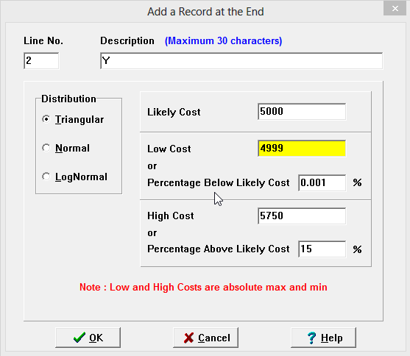

Do the same for Z. The data entry screen is shown on the next page. You can see that the sum of the likely costs is $25,000, the minimum cost is $22,499 and the maximum cost is $29,250. This means that if we want to make 100% sure that we don’t overspend on this project, we have to bump up the price considerably. The client will not be happy.

Let’s roll the dice 1000x to get a statistical view of the behavior of the cost. This is known as a Monte Carlo simulation.

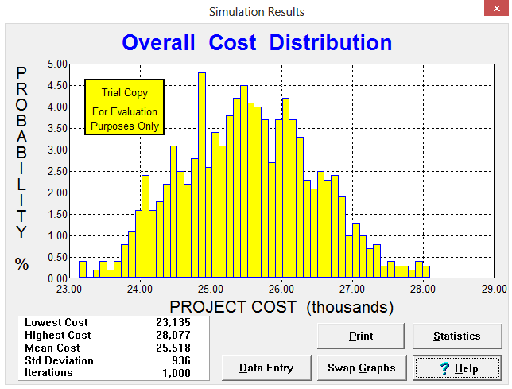

Click ‘Swap Graphs’ and look at the S-curve.

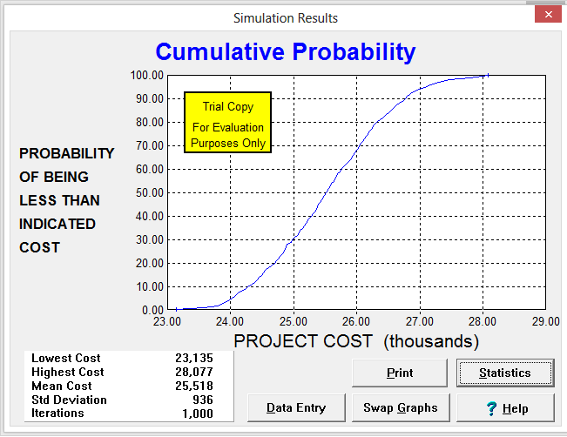

From this we can see that if we are willing to work on an 80% probability that we will have sufficient funds, we can budget for around $26,400. To get more accurate values, click on ‘Statistics’.

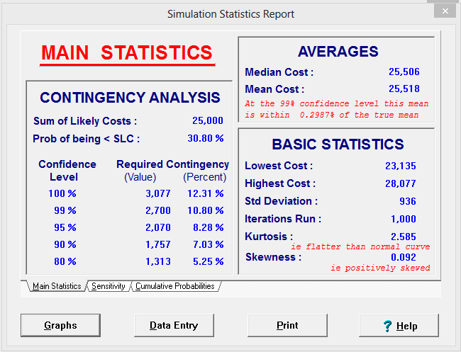

So if we add $1313 to the likely cost of $25,000 (total $26,313) we have an 80% certainty that we will have sufficient funds.

The $1,313 amounts to 5.25% of the original estimate (likely cost) and is known as a ‘contingency’