Fundamentals of

Professional Engineering

(FPE)

Tradeoff Tutorial

V1.4

***ODEL ANSWER***

.



**…**

**Source Material**

Download and install an evaluation copy of [TradeOff](http://www.ancil.co.za/tradeoff/). You can also get it [here](http://eitdata.info/fpe/FPE_Software_TradeOff_Setup.exe).

This case study/tutorial is a combination of the first 3 exercises found in the **Tools** section of the **TradeOff** software package. Some details have been changed, and the screenshots are from a PC using the Microsoft Vista operating system.

**Background**

Assume that you are James, the personnel director of a company. Through various circumstances, the post of market research officer has become vacant. You have advertised the job, and received a number of applications. You have eliminated those clearly not suitable for the position, and are left with 3 candidates, Paul, Mary and Harry.

Harry Jones, currently a marketing manager with a small cosmetic factory, is 30 years old, married, and holds a degree in commerce. He smokes rather heavily and is not exactly skinny. He has many business contacts and has an excellent social disposition, mixing easily with other people.

Mary Claridge is a 42-year-old marketing consultant with a reputable consultancy, with a lot of experience in marketing consumer products. She states that she is fed up with consulting work and would like to get her hands dirty for a change. She enjoys good health. She is married to a school teacher, and has two teenage kids.

Paul Petersen is a young bachelor with no college qualifications, but is a part-time student at a local

business school. In fact, you know his dad from the tennis club, and also know that he is a person with high moral standards and self-control. His son is extremely energetic and hard-working, and is very interested in the job itself. Like his dad, he is a good tennis player and in excellent health.

The question now arises: Who should you appoint?

**Step 1: Define the Problem**

In order to decide who should be appointed as your market research officer, you decide that it is time for a staff selection application of TradeOff. You decide on using the following 4 criteria as a job description for the vacant post.

Ability to think analytically

Ability to analyse statistical data

Number of existing contacts in the industry

Number of years experience

**Note:** The evaluation version of TradeOff only allows up to 4 criteria.

These criteria will be used to evaluate the three applicants, Harry, Mary and Paul.

You ask your assistant personnel director, Sue, to take part in the selection process, and convene a meeting where the 3 applicants would also be present. But first, you need to create a project in TradeOff.

**Step 2: Creating a Project**

Through the sequence **File | New Project** from the **Main Menu,** select, or create, a suitable folder for the project files to reside.

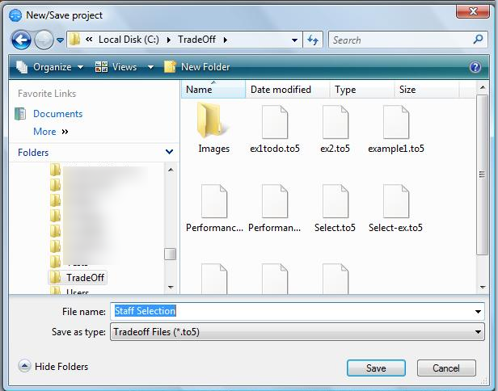

Fig. 1

Then type in a name for the project. In this case we have chosen **Staff Selection**.

Click the **Save** button to complete the new project initiation.

This will automatically create a data-base with the name **Staff Selection**. Various files will be created, everyone with a different file extension. In particular, the file with the file extension **.to5** is used to store the key parameters of the project. Should this file be lost or damaged, the project cannot be salvaged.

**Step 3: The Setup Screen**

Immediately after accepting the instruction to create the project, the setup screen is displayed, a portion of which

is displayed below. The screen contains a number of values indicating the number of parameters registered

for the different modules.

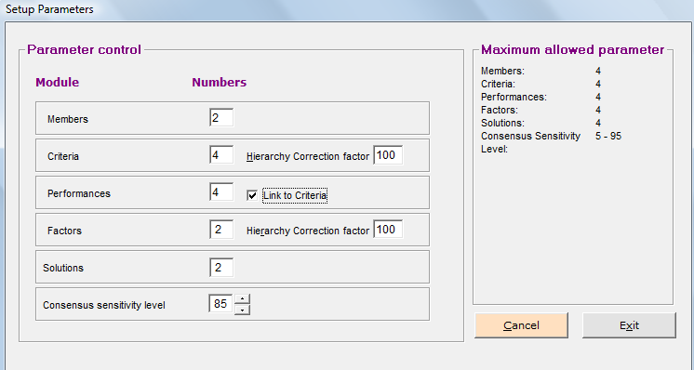

Fig. 2

Change the **Members** to 2 (you and Sue), and the **Criteria** to 4 (the job description criteria). Also ensure that the **Link to Criteria** checkbox is checked as shown. This will ensure that the number of **Criteria** and the number of **Performances** are the same, and that the descriptions for the parameters are always identical. Click **Exit** when editing is completed. Obviously there will also be instances where you are the only member.

**Note:** Solutions should have been changed to 3 as this is the number of candidates. In **Step 7** we will see how this can be changed at a later stage.

You are now back at the main screen. Notice the information in the **Default Management** frame, similar to the frame below:

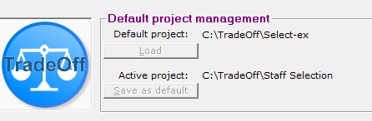

Fig.3

The project we have created is now displayed as the **Active project**, together with the file location as a prefix.

Currently, the **Default project** is a project displayed as **Select-ex**, which is a previous project (this will be different on your computer), which will be loaded when the **Load** button is clicked. We want to save our active project as the default project for quick loading next time we want to work on the **Staff Selection** project. To do this, simply click the **Save as default** button. Should the **Save as default** button be greyed out, open the **Staff Selection** project by selecting **File | Open project** from the Main Menu to display a window similar to the one below.

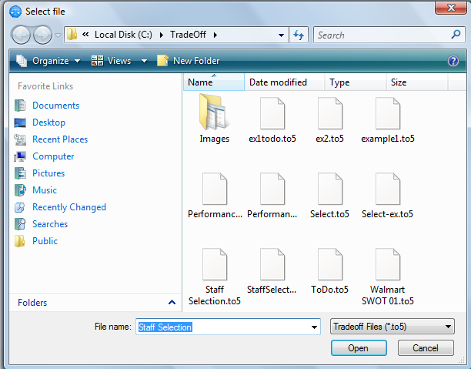

Fig. 4

Make sure your project is displayed as the file name, and click **Open**. You will now be able to click the **Save as default** button.

**Step 4: Editing Members**

You are now at the point where you have to tell the system who is going to do the decision-making, so you have

to edit the **Members.** This is done by the **Edit | Members** sequence from the **Main Menu**. A window similar to the following will be displayed.

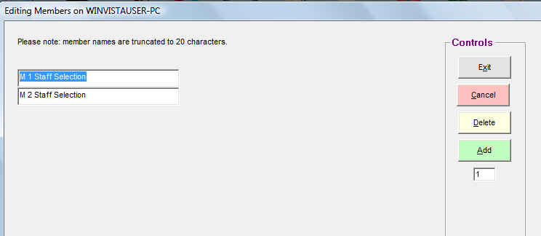

Fig. 5

Edit M1 and M2 Staff Selection to James (you) and Sue, and click on **Exit**.

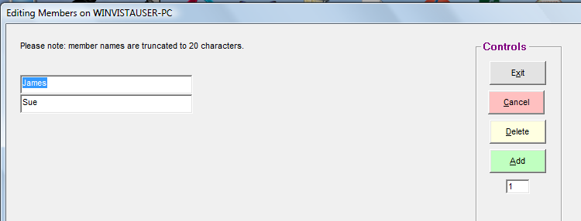

Fig. 6

**Step 5: Edit Headings**

For this case study we want to generate reports with a more professional appearance to place on the

file of the new appointee, so we need to change the heading of each **Module** to something more

descriptive. To do this, edit the **Headings**, by using by using the sequence **Edit | Headings** from the **Main Menu** and change **Criteria** to **Job requirements** and **Solutions** to **Candidates** as below.

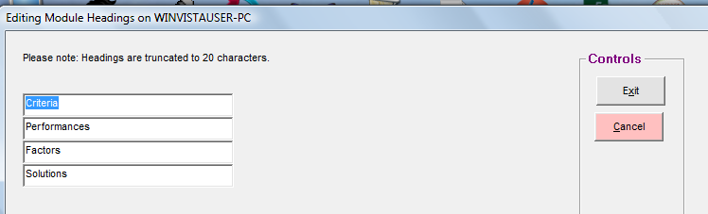

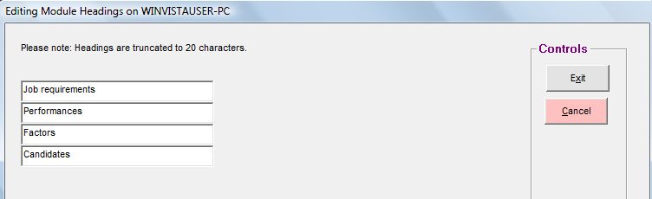

Fig. 7

**Step 6: Enter Requirements**

Next, enter the **Job requirements** descriptions through the sequence **Edit | Job requirements** from the **Main Menu**. You may want to abbreviate those to the following.

Analytical thinking

Statistical analysis

Industry contacts

Years experience

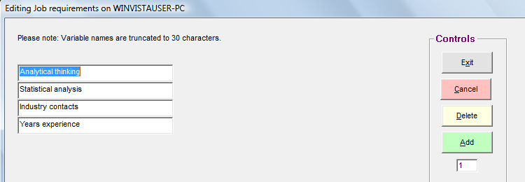

Fig. 8

Click **Exit** when completed.

**Step 7: Editing Candidates**

Using the sequence **Edit | Candidates**, enter the names of the candidates. Because we have ‘accidently’ left the number of **Solutions/Candidates** at 2 during setup, we see the following screen.

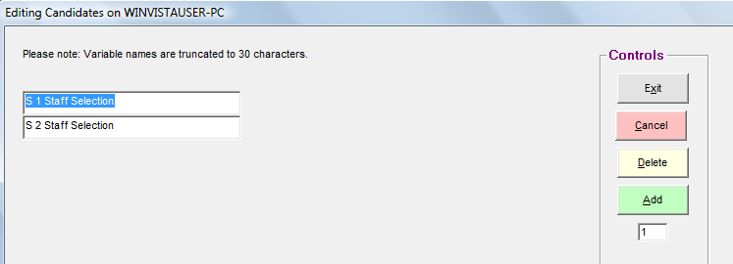

Fig. 9

To remedy this, click on **Add**. If more than 1 addition is required, change the figure in the window below **Add** to the required number. Now enter the candidates’ names, and then click **Exit**.

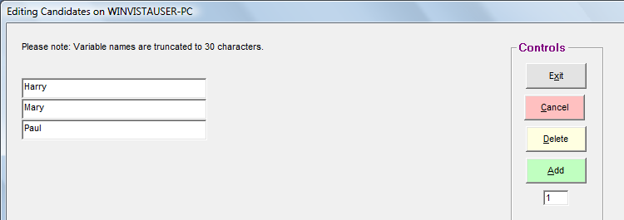

Fig. 10

**Step 8: Evaluating the Criteria**

You are now ready to evaluate the **Job requirements** to obtain a value profile which you can use with your staff selection. To generate a **Value Structure** for the committee that is required to evaluate the applicants, you need to prioritize the list of **Job Descriptions**. You realize that the priorities of your committee members will most probably differ from one individual to the next, and this being quite a subjective matter, you need to use the qualitative input method to prioritize the list.

Through the sequence **Ratio | Job requirements** from the **Main Menu**, you invoke the

**Qualitative Values** screen.

At the top left corner of the screen, you will find the **Member controls** frame, with a pull-down list box.

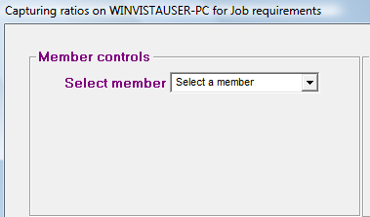

Fig. 11

Click the pull-down arrow to obtain the list of members, and select James.

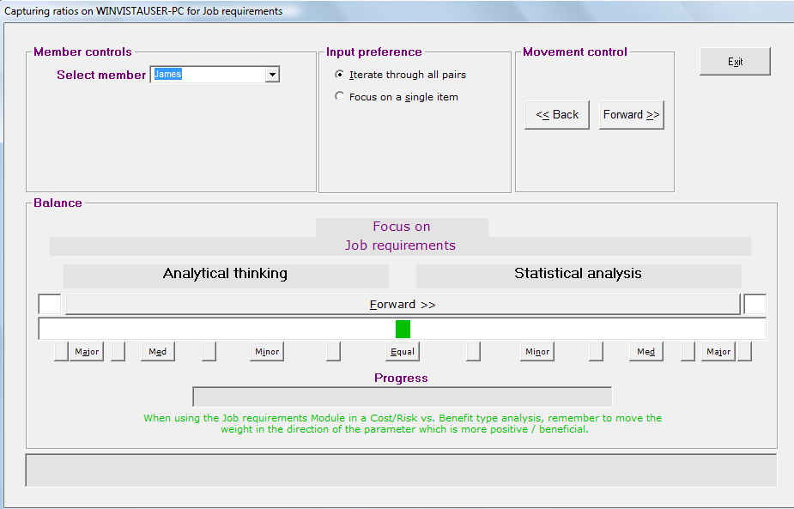

Fig. 12

You are now confronted with the **Pair-wise Comparison Balance**. A balance weight appears in the

centre of a slider strip as a small rectangular box. To enter your evaluations, proceed by dragging the balance weight to the left, or right, in the slider, depending on your judgment about the relative importance of the two parameters displayed, namely **Analytical thinking** and **Statistical analysis**.

There are four ways to enter your values:

* Drag the balance weight with the mouse pointer to the appropriate location, and accept the

result by clicking one of the command buttons marked **Forward>>** or **<<Back** in the

**Movement control** at the top of the widow;

* Same as above, but click on the long bar button also marked **Forward >>** above the weight

slider to move forward only to the next pair of parameters;

* Double-click at the position of your choice inside the slider itself to position the weight at that

position, and move forward to the next pair.

* Click one of the buttons marked **Equal, Minor, Medium or Extreme** to quickly jump the weight to a position directly above the particular button, and accept the position, all in one click.

Having entered you evaluations for the first pair, the system will prompt you for you evaluation of the

next pair. Proceed with the process until all your pair-wise evaluations have been captured.

After you are through with your own evaluations, and the progress bar displays a solid green color, again click on the member pull-down list to select the next member from which you require inputs. This will also save your inputs to the data-base of the project.

Once all members have participated, click on the **Exit** button on the top right, which will pass you back

to the **Main menu**.

To look at the results of your prioritizing effort thus far, you could view the results by the sequence **Reports | Job requirements** on the **Main Menu.** This will display the following screen.

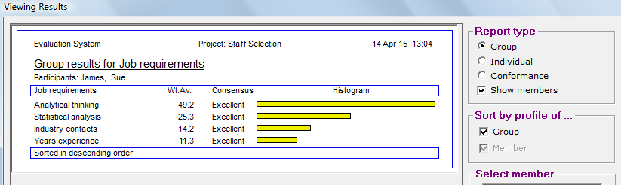

Fig. 13

The report shows the participants (that is you and Sue) in the decision-making committee, the **Job description** items, and the weight which the system has added to the list, totalling up to 100 points (with a bit of round-off error, which should not concern you, because in the memory of the computer the figures are kept accurate to 16 digits). It also shows the level of consensus between members.

To show how the individual members rated the criteria, select **Individual** as a **Report type** (top, right of the window), and the select the member.

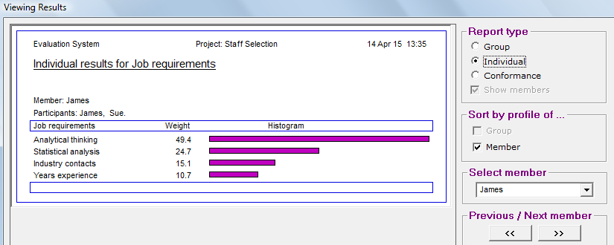

Fig. 14

**Note:** Keep in mind that your results will most certainly differ with the figures obtained in this example.

**Step 9: Evaluating the Candidates**

The process of staff selection has taken us so far to the point where we have identified three potential

market research officers; each being qualified enough to fill the vacant position. The question now is:

which one of the three is the best candidate for the job?

Having a value system against which this decision can be made makes this decision a relatively easy

one. Because each criterion now has a value attached to it, we can use these values to apply greater or lesser emphasis to the criteria. All that remains to be done is to evaluate the candidates against the

backdrop of the criteria, focusing on each criterion, one at a time.

Two methods are used to perform the evaluation:

- The Quantitative or **Numeric·ordinal** method

- The Qualitative or **Pair-wise Comparison** method

The **Numeric-ordinal** method provides a fast and easy way of evaluating the options. The quality of the ensuing decisions is, of course, dependent upon the quality and reliability of the actual numbers available. As long as this is the case, the quality of the resulting decisions is not under suspicion.

Decision·Variables are, however, either qualitative (judgmental / gut-feel) or quantitative (numeric) in

nature, and it is a fact of life that true managerial decisions are mostly of a qualitative nature, as most

experienced managers will attest. Even if some variables are of a quantitative nature, managers often

do not have the time or resources available to obtain the correct information upon which to base their

decisions.

Under these circumstances, the **Pair-wise Comparison** method still provides surprisingly high quality

decisions, because it:

- forces the decision-maker to consider every parameter very carefully

- distinguishes between good and poor decision-makers, allocating more weight to the contributions

of the better decision-makers.

Both the pair-wise comparison method and the numeric ordinal method will be discussed and used to evaluate the candidates in the following sections. Armed with the value structure of the selection committee and the application forms of the candidates, in which you have asked questions pertaining to all of the parameters, you are now ready to invite the candidates over for an evaluation session during which you will use TradeOff to

evaluate them for their suitability to the advertised position.

**Step 10: Qualitative Evaluations**

For qualitative evaluations we will look at the qualitative criteria **Analytical thinking**, **Statistical analysis**, and **Industry con**tacts. From the **Main Menu** use the sequence **Ratios | Job requirements vs Candidates** to access the **Qualitative Values** window. Select a member, e.g., James, and then select a focus from the second

list-box marked **Select Focus**, as shown below.

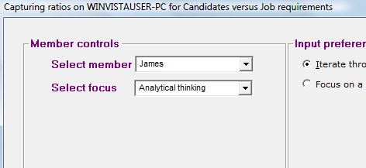

Fig. 15

Once again you come face to face with the pair-wise comparison window, but this time around your

focus is on the chosen job requirement of **Analytic Thinking** only, which is displayed in the centre of the window to remind you.

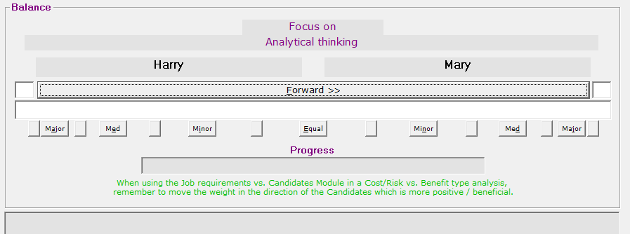

Fig. 16

The application forms can now be reviewed, and the candidates, sitting in front of you, questioned

accordingly to determine their capabilities pertaining to their analytical thinking. The scope of questions

depends on you. After gaining insight into this parameter, move the balance weight to the candidate

which your judgment tells you is more capable of analytical thinking. Proceed through all pairs of

candidates in turn, and then select the next focus parameter. Allow each committee member to submit their evaluations.

With the standard version of TradeOff, committee members can submit their evaluation either by taking turns at the computer, or by printing out a worksheet. To print a worksheet, follow the sequence **Reports | Worksheet** from the **Main** window. A window similar to the one shown below will be displayed.

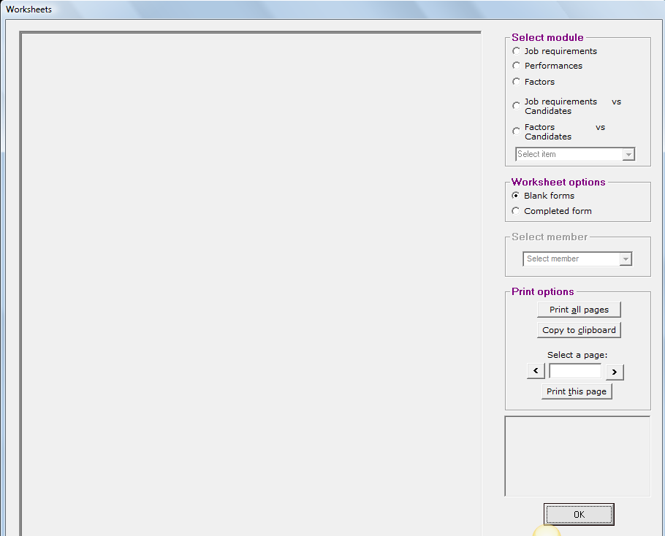

Fig. 17

Note the **Select module** frame in the control section on the right of the window, allowing you to select a module for which you need a worksheet.

Click on the **Job requirements vs Candidates** module, and then select a **Job requirement** from the drop-down menu to obtain a blank worksheet as displayed below.

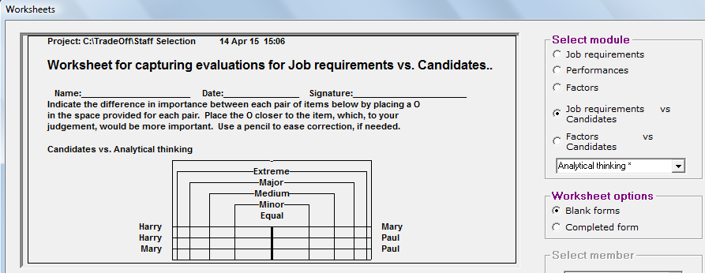

Fig. 18

Committee members complete the questionnaires on paper, after which you simply enter

their evaluations into the system.

**Step 11. Quantitative Evaluation**

We now return to the parameter **Years experience**, which is a purely numeric parameter, and for

which we need no judgment. We simply ask the candidates how many years of relevant experience they have in the industry. But how do you tell that to the system?

It turns out that for 4 years Harry has managed the market research for his previous company on his

own, which means that he surpasses the requirement by one year. Mary has done consulting work in

market research for a large number of companies for 11 years, while Paul does not have experience in this field at all. However, he is doing a part-time course in marketing, which you happen to know is pretty good, at the local business school. In your book, the collective experience in case studies and assignments at the school are good enough to earn him the status of 1 year's experience.

From the Main Menu, use the sequence **Ratios | Numeric inputs** to reach the **Numeric inputs** screen. Pull

down the **Select module** list box, to produce the following display.

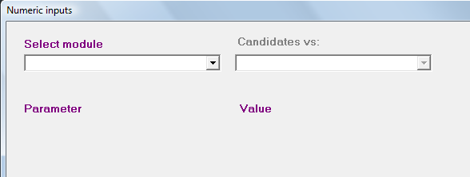

Fig.19

Select the **Job requirements vs Candidates** module (that is, the **Criteria vs Solutions Module** which

was renamed). Another pull-down list-box appears, prompting you for the parameter for which you need to enter numeric values.

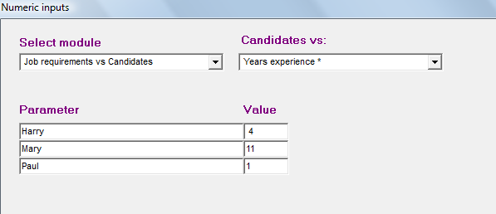

Fig. 20

When completed, click **Exit** to accept and save the values. The system will automatically assume the same values for every member and will present you with the following window to alert you to the fact.

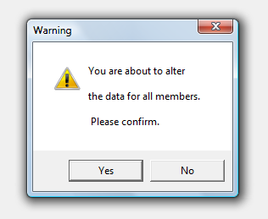

Fig. 21

**Step 12: Display/Interpret the Benefit Report**

To see which of your candidates conform the best according to the requirements of the job, use the

sequence **Reports | Job requirements vs Candidates** from the **Main Menu**, to obtain the following

report, which is called a **Benefit Profile of the Solutions.**

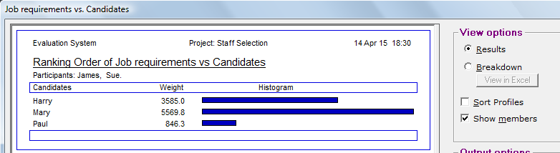

Fig. 22

This report clearly indicates Mary as the candidate to be appointed to the position of market research

officer.

The **View Options** frame provides different display formats for the above report. For now we are

interested in how the above result had been calculated and what the consensus structures for the

report are per **Job requirement**. On the **View options** frame, click the **Breakdown** option button to

produce the desired trade-off report, as illustrated below.

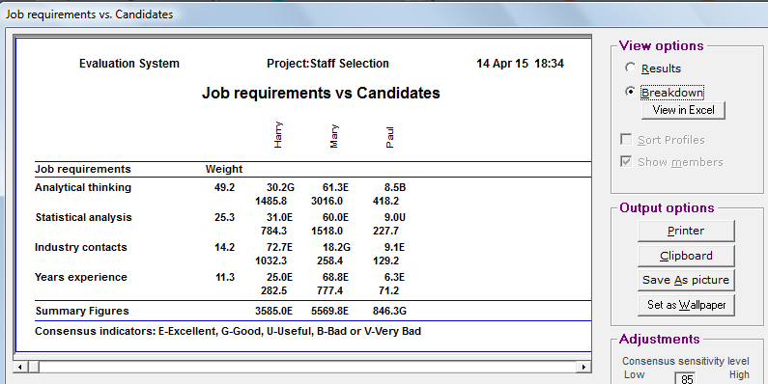

Fig. 23

This report provides an explanation of exactly how the result has been calculated. At the top of the

report are the names of the solutions, or candidates. Down the side are listed the criteria, or **Job requirements**, with their weights. You have had the opportunity of evaluating every candidate against the backdrop of every criterion.

Observe, for instance, the first job requirement, namely **Analytic thinking**, carrying a weight factor of 49.2 points. From the inputs supplied by your committee, the system has divided 100 points amongst the three candidates, allocating 30.2 points to Harry, 61.3 to Mary, and the rest, 8.5, to Paul, thus indicating that Mary scored highest for **Analytic thinking**. These figures are called the **Emphasis Coefficients**, indicating how well each solution conforms to the requirement of the criterion of **Analytic thinking**. Mary scores best, and Paul least, with Harry in the middle.

An **Emphasis Product** is calculated by multiplying the relevant **Emphasis Coefficient** with the value of the parameter **Analytic thinking**, which is listed directly below the **Emphasis Coefficients**. This is done for all **Emphasis coefficients**. The **Summary Figures** appearing in the bottom line are the sum of the **Emphasis·Products** of the column directly above. This result is a well-balanced indication of the relative benefits expected of the solutions, in this case your candidates.

The first report above contains the figures obtained in the bottom line of the **Trade-off** **matrix,** and also displays it graphically for a more favorable impression of the magnitudes of the benefit figures. Notice also the **Consensus Indicators** associated with every **Emphasis Coefficient**, as well as with the **Benefit** or **Summary figures**.

Analyzing these, it is clear that your committee is in consensus on almost all pertinent points, with the exception of Paul’s **Analytical thinking**, which is associated with a **Bad** consensus indication, something which may justify your further attention. There is a **Useful** indicator as well, which should not unduly disturb you, unless there was a very close tie between two candidates.

**Note:** Again, keep in mind that your figures will most certainly differ with the figures obtained in this example.