Fundamentals of

Professional Engineering

(FPE)

WBS Tutorial

V1.4

***ODEL ANSWER***

.



**…**

**1.0 Problem**

We are going to create a WBS for the design, building and testing of a prototype for a small dinghy that can be used for offshore racing. In real life the WBS will be much more involved, but we simply want to get the point across.

We will call the project ‘Dinghy Project’. This is **Level 1.**

We will subdivide this into Planning, Construction and Testing. This is **Level 2.** Planning, Construction and testing are ‘siblings’, and they are all ‘children’ of the parent viz. Dinghy Project. This parent-child relationship exists throughout the WBS.

We will subdivide Planning into Design and Procurement; Construction into Hull, Propulsion and Steering; and Testing into Structural Testing and Sea Trials. These are all at **Level 3.**

We can go on *ad infinitum*, but let’s stop at subdividing Propulsion into Mast and Sails (because they will be supplied by different subcontractors). This will be at **Level 4**.

Note:

* Only the lowest level in each branch represents a work package
* All work packages have single owners
* They can be contracted out if necessary
* There are NO dependencies implied
* There is NO scheduling implied

In other words; the work packages can be executed in any sequence and at any time. This will be addressed in the PERT and Gantt charts and NOT in the WBS. Some WBS software packages do allow us to inter cost and scheduling information (such as start/end dates and dependencies) into the WBS, but it has no impact on the structure of the WBS diagram.

**2.0 WBS ALTERNATIVES**

There are several ways to do the WBS and we will look at four options although ONE is usually sufficient.

**2.1 OUTLINE VIEW**

This resembles the Contents page in a manual.

1. Dinghy Project

1.1 Planning

1.1.1 Design

1.1.2 Procurement

1.2 Construction

1.2.1 Hull

1.2.2 Propulsion

1.2.2.1 Mast

1.2.2.2 Sails

1.2.3 Steering

1.3 Testing

1.3.1 Structural

1.3.2 Sea Trials

**2.2 HIERARCHICAL STRUCTURE**

This one is more difficult to read, but it is OK in a case where there are many levels and the page would otherwise be too narrow.

|  |  |  |
| --- | --- | --- |
| Level | WBS Code | Element Name |
| 1 | 1 | Dinghy Project |
| 2 | 1.1 | Planning |
| 3 | 1.1.1 | Design |
| 3 | 1.1.2 | Procurement |
| 2 | 1.2 | Construction |
| 3 | 1.2.1 | Hull |
| 3 | 1.2.2 | Propulsion |
| 4 | 1.2.2.1 | Mast |
| 4 | 1.2.2.2 | Sails |
| 3 | 1.2.3 | Steering |
| 2 | 1.3 | Testing |
| 3 | 1.3.1 | Structural |
| 3 | 1.3.2 | Sea Trials |

**2.3 TABULAR VIEW**

This one is easier to read, but becomes rather wide with severeal levels of decomposition (as would be the case in , say, a power station construction project).

You can use MS Word or MS Excel for any of the tabular ones.

|  |  |  |  |
| --- | --- | --- | --- |
| Level 1 | Level 2 | Level 3 | Level 4 |
| 1 Dinghy Project | 1.1 Planning | 1.1.1 Design |  |
| 1.1.2 Procurement |
| 1.2 Construction | 1.2.1 Hull |  |
| 1.2.2 Propulsion | 1.2.2.1 Mast  1.2.2.2 Sails |
| 1.2.3 Steering |  |
| 1.3 Testing | 1.3.1 Structural |  |
| 1.3.2 Sea Trials |

**2.4 TREE STRUCTURE**

This one is by far the easiest to interpret, but requires some software. Here are some suggestions.

(a) Use the Insert -> SmartArt function in MS Word.

(b) Use an online WBS utility such as [WBSTool](http://www.wbstool.com/).

(c) Download and install a dedicated WBS software package such as WBS Schedule Pro (WBS Version)). Unfortunately it is rediculously expensive, so we will just use the 30-day trial of an earlier version, [WBS Chart Pro](http://eitdata.info/fpe/FPE_Software_WBSPro_Setup.exe), for this tutorial. The older version is easier to use anyway.

The following screenshots are for WBS Chart Pro.

Run WBS Chart Pro and hit the ‘Insert Task Below’ button (see cursor below). We will refer to this as the ‘V’ button.

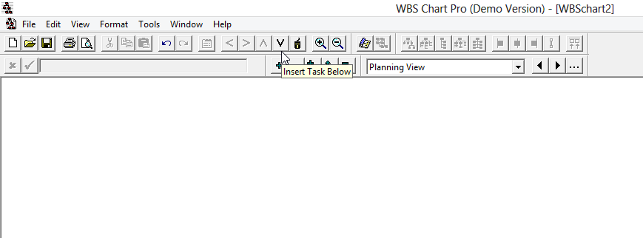

Type *1. Dinghy Project* and the name of the newly-created task will be updated. Now hit the V button again, and type *1.1 Design* in order to re-name the child task. Once you have created a new node you can begin typing straight away in order to edit the name.

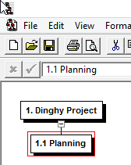

Make sure that ‘1.1 Planning’ is highlighted, and then hit ‘Insert Task Right’ (the ‘larger than’ button i.e. ‘>’) to complete Level 2.

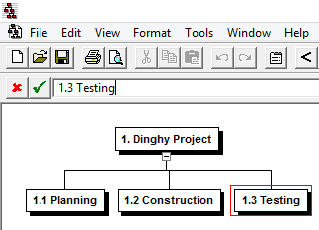

Now use the ‘V’ and ‘>’ buttons to complete Level 3 as well.

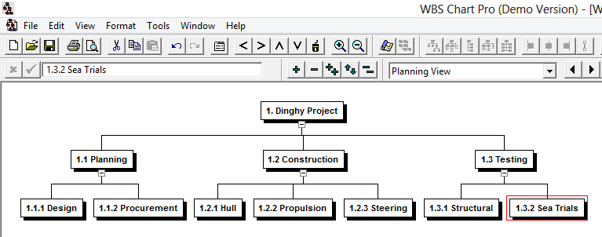

Now select 1.2.2 Propulsion, and add the two siblings below it.

That’s it!

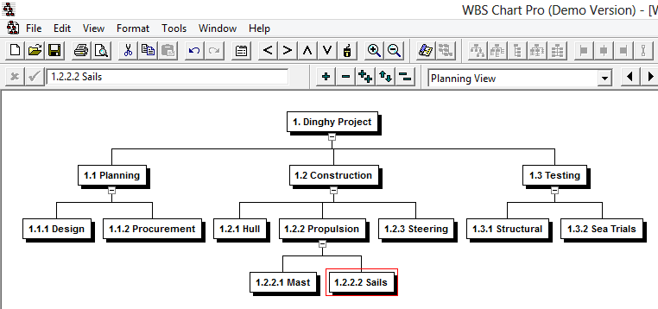

If you highlight *1. Dinghy Project* you can select various views, such as the following:

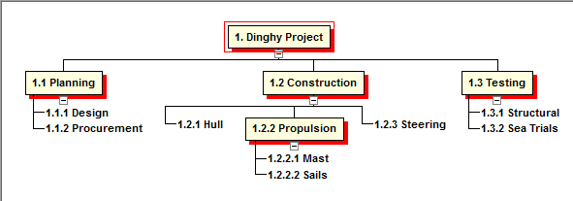

However, please look carefully at the following example:

**THIS IS FINE**

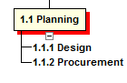

**THIS IS ABSOLUTELY NOT**

Some newbies are under the impression that 1.1.1 Design and 1.1.2 are siblings of the parent 1.1 Planning, whereas 1.1 Planning is the parent of 1.1.1 Design, and 1.1.1 Design is, in turn, the parent of 1.1.2 Procurement. It is a sort of grandparent-parent-child relationship in which there is ONLY one work package viz. 1.1.2 Procurement.

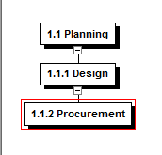

**3. THE WBS DICTIONARY**

And now we get to the final part. According to the PMDOCS WBS template:

*“The WBS Dictionary contains all the details of the WBS which are necessary to successfully complete the project. Most importantly it contains a definition of each Work Package which can be thought of as a mini scope statement. Resources on the project will look at the WBS dictionary to determine the scope of the Work Package they've been assigned, so it's important to be clear when writing the definition. Most WBS dictionaries contain more information than we show in our sample. These things usually include Level of Effort, Cost Control Numbers, Resource Assignments, Responsibility Assignments - just to name a few.”*

Simply take the hierachical structure and add another column.

|  |  |  |  |
| --- | --- | --- | --- |
| Level | WBS Code | Element Name | Definition |
| 1 | 1 | Dinghy Project | The construction of a Mk IV racing dinghy prototype |
| 2 | 1.1 | Planning | All planning related to the project |
| 3 | 1.1.1 | Design | Design of the dinghy with AutoCAD, including hydrodynamic simulations |
| 3 | 1.1.2 | Procurement | Procurement of all raw materials required for the hull, rudder and daggerboards |
| 2 | 1.2 | Construction | Construction of the prototype |
| 3 | 1.2.1 | Hull | Construction (on site) of hull, rudder and daggerboards plus adding of mast and sails |
| 3 | 1.2.2 | Propulsion | Includes mast, sails and rigging |
| 4 | 1.2.2.1 | Mast | Foberglass mast to be supplied by external vendor |
| 4 | 1.2.2.2 | Sails | Set of reacing sails to be supplied by external vendor |
| 3 | 1.2.3 | Steering | Fabrication and fitting of rudder and daggerboards |
| 2 | 1.3 | Testing | Testing of the prototype |
| 3 | 1.3.1 | Structural | Destructive testing of composite parts such as daggerboards |
| 3 | 1.3.2 | Sea Trials | Extensive testing at sea, in racing conditions |