**ALTERNATIVE ANALYSIS**

For this section you need to do *at least* a grid analysis. Some groups augment that with other techniques, such as a ‘force field analysis’ or a SWOT analysis. Refer to webcast 1D for details on decision making.

For the grid analysis, use at least four selection criteria. There is an example in the notes, but the process for deciding which car to buy (in the assignment) is 100% analogous to this one. The only difference is that the assignment question did not require group consensus.

The example below comes from your reading material.

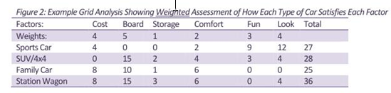

In the real world consensus in decision-making is critical, and in that regard [TradeOff](http://www.ancil.co.za/tradeoff/) really becomes a valuable tool. Unfortunately the evaluation copy only allows for 4 participants, in which case you will need to get group consensus via, say, a Skype meeting and have have one person feed the data into TradeOff at the same time.

You can get the [TradeOff tutorial](http://idc.clearacnesecrets.com/wp-content/tutorials/fpe/FPE_Assignment_Help_TradeOff.docx) here, if you have not downloaded it earlier on.

Here we will choose the best solution. However, leave the *detail design* for later in the project.