**RISK ANALYSIS**

In this section you will identify the risks, and perform a **qualitative** risk analysis using the 5x5 matrix approach.

Refer to AS/NZS ISO 31000. You can get a copy from the Indian Bureau of Standards, which is identical to the International version, [here](https://archive.org/details/gov.in.is.iso.31000.2009).

You will need to create a 5x5 matrix to map your risks. Google ‘risk matrix’ and you will get examples like this:

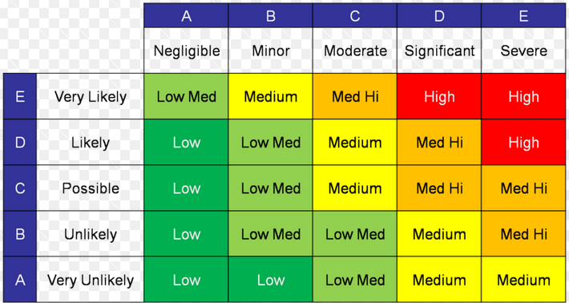

Create your own copy with Excel.

Next, identify (list) all the possible risks for your project. Once again you can use a search engine to find sites like [this](http://management.simplicable.com/management/new/130-project-risks). Also consider the following Critical Success Factors as potential risks (although not all if the points mentioned will apply to you):

* Issues related to the specific project e.g. size, complexity, technology, number of interfaces
* The project manager and team e.g. expertise, systems, personality, resources, levels of authority
* The customer organization e.g. commitment, response times, knowledge
* The external environment e.g. social, cultural, political, economic, financial, technical, legal, contractual

Finally, create a [risk register](http://www.projectmanagementdocs.com/project-planning-templates/risk-register.html) such as the one from PMDocs.

Cross-reference your risk register and your matrix.