**UPDATED WBS**

In Segment 3 you created a basic WBS, which looks like this:

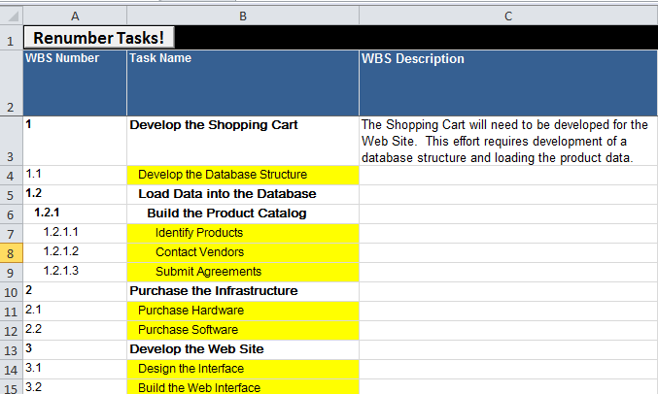

Note that ONLY THE YELLOW ENTRIES REPRESENT WORK.

You now have to complete the test of the spreadsheet.

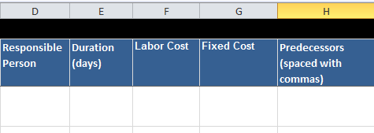

The labor cost (column F) is the total number of each resource (person) times the hourly rate for that resource. You can work this out with a calculator, but GanttProject version 2.7 onwards will also do this for you (see [here](http://www.ganttproject.biz/ostrava)) on a per-task basis although it cannot aggregate the costs to give you a grand total.

Not all resources may be required for 100% of the time. If someone is only involved say 50% of the time, GanttProject can take this into account (see the webpage referred to in the previous paragraph).

Material costs or fixed subcontractor costs go into column G.

To get the total project cost you have to Autosum columns F and G.

Column H is for the dependencies. For this project we will stick to simple Finish-Start relationships. So, if 3.2 (Build the web interface) depends on 3.1 (Design the interface) as well as 2.2 (Purchase software), you will enter 2.2, 3.1 in this column.

Once you have updated the spreadsheet, you can transfer the information to GanttProject.