**PROJECT CASH FLOW**

The updated WBS shows the total expenditure. However, we now want to predict the project cash flow on a monthly basis.

Assume the following:

* Material costs (if any) are incurred in the first month of any given work package.
* Labor costs are uniformly spread across any given activity.

Create a spreadsheet along the following lines, for the duration of the project. The activities are the work packages as per your WBS, and the duration (the yellow bars below) are from your Gantt chart.

Do not try to split hairs here. If a task starts somewhere in Month 1 and ends somewhere in Month 3, then show a bar running across all three months.

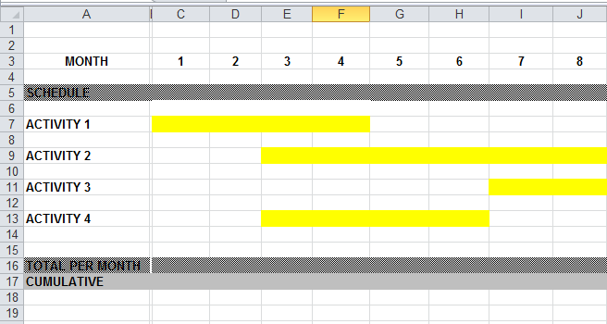

Let’s assume ‘Activity 1’ is actually Prototype Development. The material cost is $15,000, so we enter that in cell C7. Also assume that the total labor cost is $40,000. We apportion that in equal amounts to months 1, 2, 3 and 4 i.e. we enter $10,000 into cells C7, D7, E7 and F7. Of course there is already a $15,000 material cost in C7, so there we hit F2 and edit the cell so it contains 15,000+ 10,000. And so on.

Now add up each column (C16, D16 etc.) to get the monthly total.

Next, create a running (cumulative) total in cells C17, C18 etc.

Finally, graph the two rows (16 and 17).