**HOW TO CREATE A WIX SITE**

1. Go to [www.wix.com](http://www.wix.com), create an account, and log in.
2. WiX will ask you to create a website. Click on ‘Start Creating a website’.

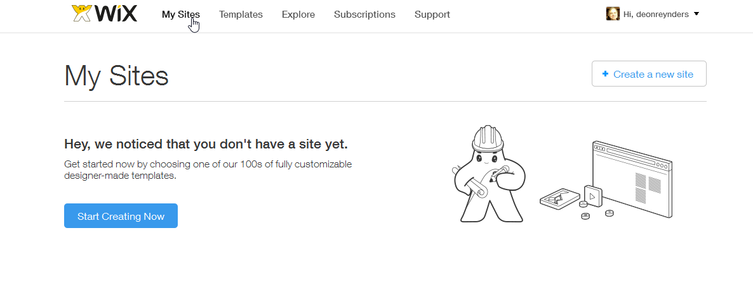

1. You now need to pick a template (below). Go to the menu on the bottom left-hand side.

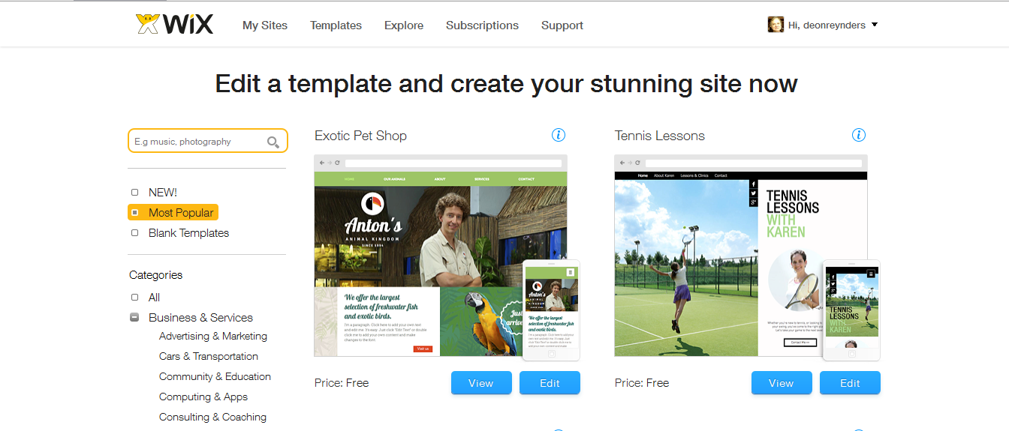

1. Select ‘Personal’, and then ‘Resume and CV’. You may, at your discretion, choose another type of template.

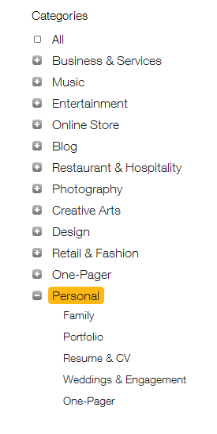

1. You will now see something like the image below. Look at all the options (2 pages).

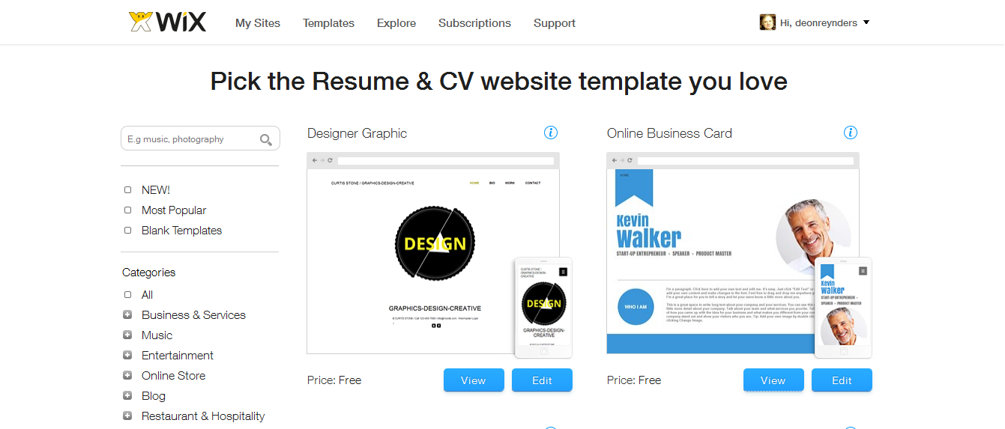

1. Let’s view the ‘Kevin Walker’ option.

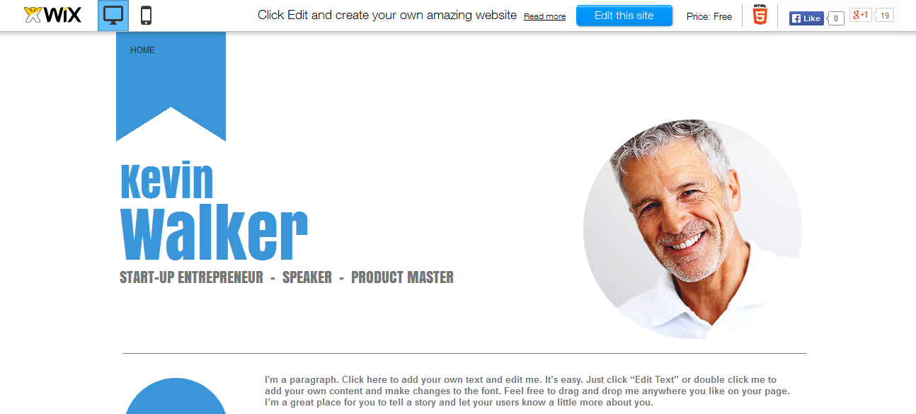

1. Click on the ‘Edit this Site’ button.

The HTML5 editor will load, and you will see the following. Note the buttons top left.

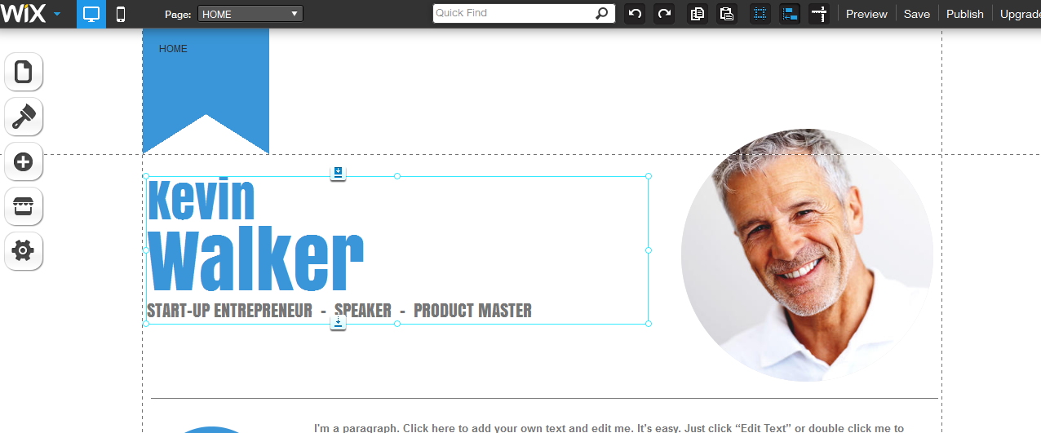

1. Click on the ‘Pages’ button.

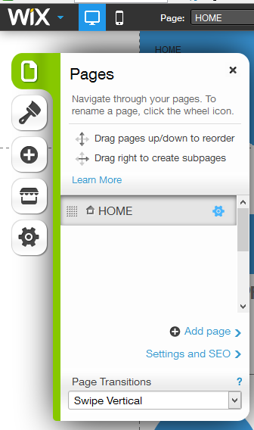

1. Now we are going to add a page, called ‘Reflections’. You can call your page whatever you like; this is just to show you how to create one.
2. Click ‘Add page’ and the following will appear. We have selected a blank page, but there are many options and you should look at them all.

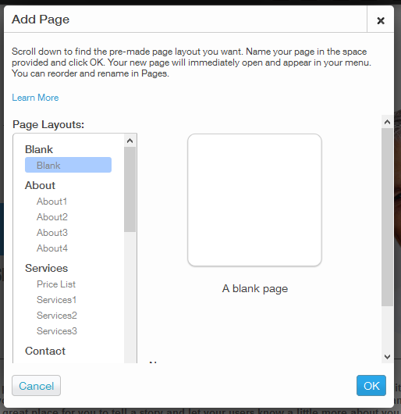

1. We have added a page, but it is still blank.

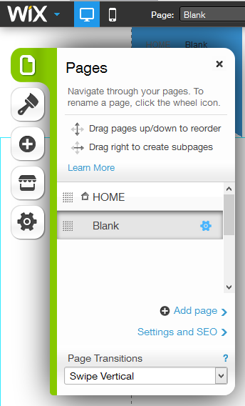

1. On the Blank page, click the gear icon and edit the page name. Then click ‘Done’.

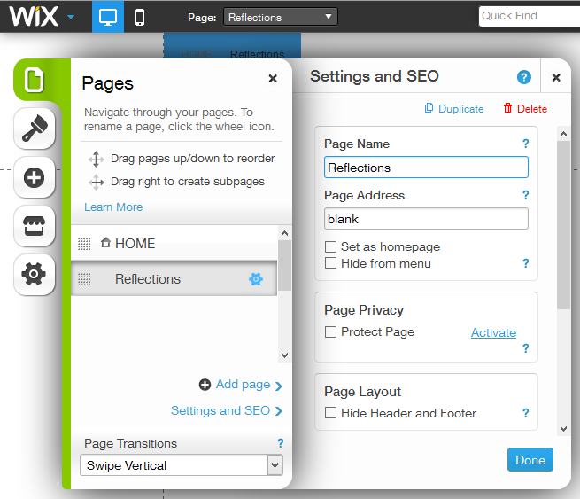

1. Click on ‘Preview’ and conform that your new page shows up. Then return to the editor.

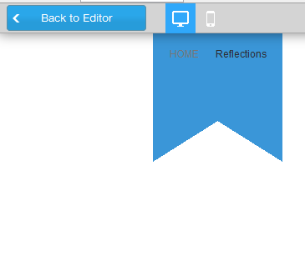

1. We now want to create a SUBPAGE for Reflections, called Module 1. Subpages are handy if you want to place various items under one heading, but not on the same page. An example could be ‘About Me’, with subpages for ‘Contact Information’, ‘Hobbies’, and ‘Extramural Activities’.
2. First, create a new page called Module 1. If it does not show up in the right place (in this case just below Reflections), then drag it there with your mouse.

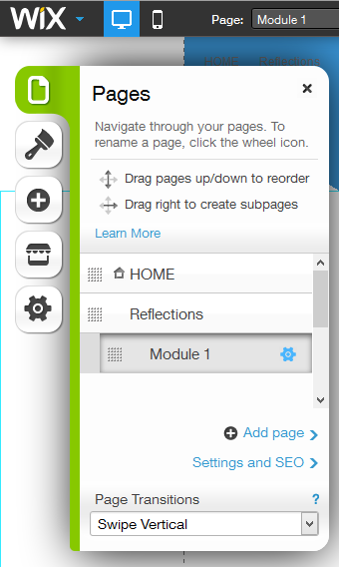

**HOW TO CONTROL ACCESS TO YOUR SITE**

1. Initially, when you are still working on your site layout, you only need to save it by clicking on the ‘Save’ button. Nobody else will be able to access it. The format of the URL will be <http://www.joebloggs.wix.com/joe>



1. Once you are happy about EIT checking your site, you can publish it. Use the button just to the right of ‘Save’. People will, however, not be able to access the site without having your URL. If you want to make it impossible for anyone to guess the URL, then make it something like this: <http://www.joebloggs.wix.com/joe5pq>
2. It is, however, still possible for someone to stumble upon your site via a Search Engine. If you want to prevent the Search Engines from indexing your site (so it will never appear on someone’s search results), then go to Settings->SEO (Google) and move the round slider button to the left as shown.

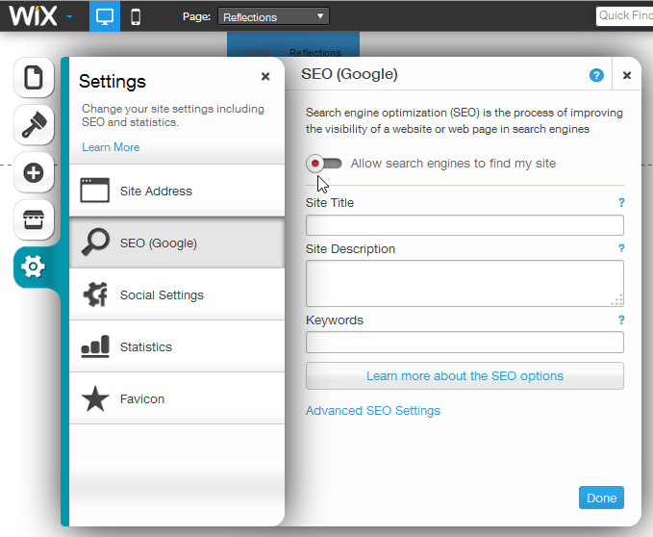

1. Controlling access to specific tabs. You may want to show your website to friends and colleagues, but if there are e.g. work or course-related pages you only want to share with EIT, you will have to password-protect them.
2. Click on the Pages icon, and then (for each page to be protected) click on the Page Settings ‘gear’ icon. Then put a tick mark in the ‘Protect Page’ box.

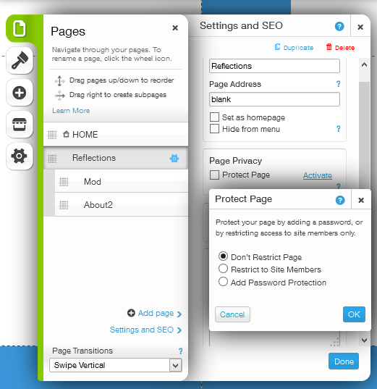

1. Click on the ‘Add Password Protection’ radio button, type a password, and hit ‘OK’. If you cannot see the OK button, you will have to zoom out.
2. To check if this works, view your site and click on the tab for the protected page.
3. You will obviously then have to share that password with those that you want to give access to the protected page.