|  |  |  |  |
| --- | --- | --- | --- |
| **Fundamentals of Professional Engineering (FPE) Module** | | | |
|  | | Overview for Coordinators | |
|  | |
|  | |
|  |  |
|  | V1.5 |
|  | |  |  |
|  | |  |  |
|  | |  |  |
| |  |  |  |  | | --- | --- | --- | --- | | Created By: | Deon Reynders | Date: | 29/08/15 | | Reviewed By: |  | Date: |  | | | | |
|  |  |  |  |
|  |  |  |  |
|  | | | |
|  | | | |



FPE Overview for Coordinators

1. Introduction

The following is a very brief overview of the FPE module.

Originally the module was intended to run somewhere at the beginning of the Advanced Diploma courses, typically as Module 3, 5 or 7. This meant that both the theoretical and project components would stretch over roughly a year.

For various reasons it was decided to move both components into the last six months of the course. The exact timing depends on the start and finish dates of other modules, but the FPE module will now commence no later than week 50.

1. Theoretical Component

##### 2.1 Webinars

The topics, as listed in the current brochures, have been condensed as follows:

**WEBINAR 1**

Topic 1A Time Management

Topic 1B Portfolio of Skills

Topic 1C Communication Skills

Topic 1D Decision Making

-----------------------------------------------------------------------------

**WEBINAR 2**

Topic 2A Project Management: Work Breakdown Structures

Topic 2B Project Management: Scheduling

Topic 2C Project Management: Qualitative Risk Analysis

Topic 2D Project Management: Quantitative Risk Analysis

-----------------------------------------------------------------------------

**WEBINAR 3**

Topic 3A Project Costing and Cash Flow Modelling

Topic 3B Discounted Cash Flow

-----------------------------------------------------------------------------

**WEBINAR 4**

Topic 4A Technical Writing and Specifications

Topic 4B Group Dynamics

Topic 4C Leadership and Professional Conduct

Topic 4B Ethics in Engineering

------------------------------------------------------------------------------

**WEBINAR 5**

Topic 5A Responsibilities of the Engineering Associate

Topic 5B Engineering Standards and Codes of Practice

Topic 5C Global and Environmental Issues

Topic 5D Sustainable Engineering

-----------------------------------------------------------------------------

**WEBINAR 6**

Topic 6A Workplace Health & Safety Issues

Topic 6B Presentation Skills

Topic 6C Technical Skills and Career Planning

Topic 6D Contract Law

------------------------------------------------------------------------------

The first four Webinars are to be presented live in four consecutive weeks, commencing around week 50, whereas Webinars 5 and 6 are to be released for asynchronous online viewing afterwards.

The screenshot below shows a *typical* schedule, but it needs to be repeated that the exact start date will vary from course to course.

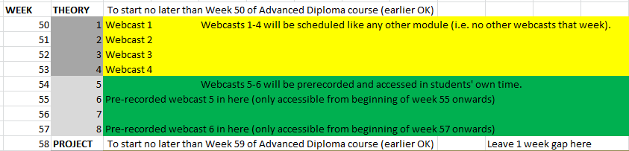

The first WEBINAR CAN NOT take place later than week 50. However, it should not interrupt the presentation of another module.

Example: In DBE, with Module 3 (FPE) initially removed from the presentation schedule, Module 13 finishes in Week 48 and Module 14 would therefore finish in Week 52. This means that the four live FPE Webinars can slot in between Modules 13 and 14, with WEBINAR 1 in Week 49 and WEBINAR 4 in Week 52.

You can create a spreadsheet like to following one to help you plan.

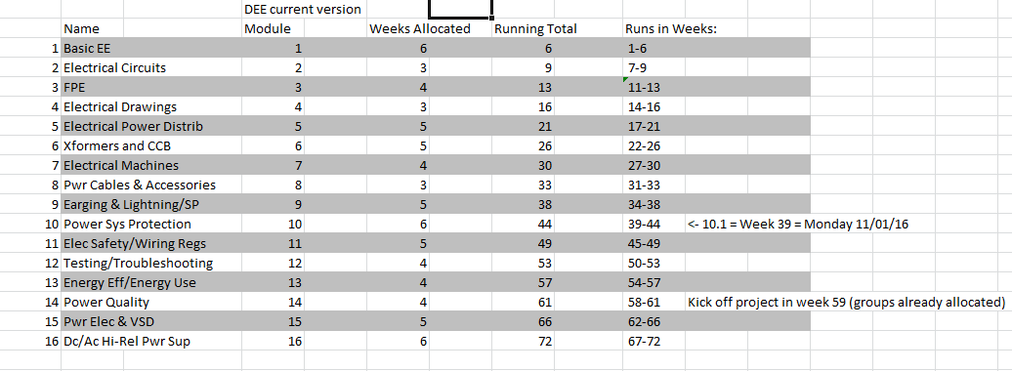

As courses get reaccredited, the four live FPE webinars will be moved to the correct position.

##### 2.2 Assignment

There is a single (substantial) assignment to be completed *individually*. This is to be made available to students via Moodle in the usual way.

The latest version of the assignment is downloadable [here](http://eitdata.info/fpe/FPE_Individual_Assignment_Current.docx). The model answers are available from Deon.

Because of the length of the assignment you may schedule submission close to the end of the course, but keep in mind that they need most of the learning to take place before they apply it in the group project. So if students put off completion of the assignment until the last few weeks of the course, it defeats the object of the exercise.

1. Group Project

The second part of the FPE module consists of a *group* project. This is a critical component In terms of the Engineers Australia accreditation.

*3.1 Division of duties*

Because there are two staff members (coordinator and lecturer) involved, it is very easy for things to ‘slip through the cracks’. Please agree up-front who will do what e.g. coordinator will handle all admin issues and lecturer will handle all technical (project-related) issues. Checking almost every second day on progress to identify struggling groups and joyriders is important and it is advisable for both the lecturer and coordinator to watch out for that.

*3.2 A bit of Advice*

Running project groups in a typical ‘real’ brick-and-mortar environment is easy, because the students interact physically on a daily basis. It is easy for the lecturer to identify individuals with leadership skills. It is also easy to spot ‘joyriders’ and call them to task.

In a virtual classroom environment things are very different. The projects require a fair amount of leadership, yet some groups (because they are assembled on the basis of time zone, not interpersonal skills) are totally devoid of such skills.

They simply fall flat along the way or, worse, do not even get off the ground because there is no leadership.

The lack of leadership is in itself not ‘bad’, because the world also needs competent followers. It is just an issue because this will prevent group members from completing the FPE module, and hence the course overall.

So here is what I would suggest.

The project is divided into phases or ‘segments’.

1. For the initial phase (‘Segment 1’) identify self-starters (usually individuals with a very good academic performance) and ask them to take up the group leadership. Once the group members know each other they can elect other leaders on a rotational basis, say, a different group leader for each month or segment.
2. Arrange the first Skype meeting yourself, make sure that everyone turns up, and ensure that the group agrees on who does what. Also check that there is a ‘scribe’ in attendance, and insist on a copy of the minutes. See additional notes regarding communication below.

If you leave this to the group, I can promise you that some groups just won’t do it. In a group of followers each individual waits for someone else to take the initiative.

If you have trustworthy group leaders you can, of course, delegate this.

1. See notes on DropBox in Section 3. My suggestion is that you set this up yourself, or that you ask the group leader to do this. There is ample ‘how to’ info on the web. But do not just wait for the group to do it.
2. Watch the group’s communication on Moodle on at least a weekly basis. You will quickly notice if there is a problem. Act as a sort of moderator on the forum, and regularly add comments.
3. Send out reminders regarding the Segment submissions as per the [Project Deliverables and Due Dates](http://eitdata.info/fpe/FPE_Project_Deliverables_and_Due_Dates.docx) document. This is easily done via Google calendar, but email will also suffice.

##### 3.3 Project Overview

For the ‘big picture’ please refer to the [FPE Project Overview](http://eitdata.info/fpe/FPE_Project_Overview.docx). To make the project work more manageable, it has been divided into six chunks or ‘segments’, each culminating in a submission to be uploaded to Moodle by a given date.

It looks like a lot of work, but keep in mind that each student only needs to do 10% of the work.

Each submission is to be submitted on a template. The links to these are to be found in Section 3.3 of the project Overview.

Liberal use is made of help files, which can be accessed via hyperlinks. This approach facilitates more ‘uncluttered’ templates and also allows for the help files to be updated easily, based on feedback from lecturers and students.

##### 3.4 Group Allocation

The Advanced Diploma cohorts need to be divided into groups of approximately 8-10 students each. Where possible, try to keep group members more or less in the same time zone.

It is a good idea to start assembling the groups a few weeks in advance of the project kick-off. Week 50, when they start the theoretical part of the course, is a good starting point.

Allocate students to groups, and then get them to sign and return the disclosure form. You may have to crack the whip or pick up the phone…some students simply don’t read their email.

**Setting up your groups**

1. On your course page go to Users > Groups > Create Group. Create a group using the naming format Coursecode_FPE_GROUP1 e.g. DEE19_FPE_GROUP1, DEE19_FPE_GROUP2 etc.
2. Add users to each group by clicking Add/Remove Users then selecting potential students and then Add. Also include the instructor.
3. Once finished adding group members click Back to Groups.

##### 3.5 Group Communication

The group members will communicate via email, Skype, Moodle Forums, and DropBox.

**3.5.1 Email**. Impress upon students the importance of sharing their PRIMARY email address. They need to access that account on a *daily* basis. Some throwaway Hotmail account that they visit once a month will not suffice. Email is primarily for you to exchange individual messages with group members. Once the forums are operational, you can communicate with them via that.

**3.5.2 Moodle Forums (‘Chat Room’).** You will need to set this up for each group. You need to impress upon group members to communicate as far as possible within the Forum. This is no different to sending emails cc’d to everyone, but it is easier. For example, the co-ordinators can log into the Forum and check the dialog without having a cluttered-up Inbox.

The idea is essentially to create a proper and easily-accessible ‘paper trail’

**Setting up your forums**

1. In the FPE module section on Moodle click Add an Activity or Resources and then select Forum > Add.
2. Name the forum *Group One Project Forum, Group Two Project Forum* etc and so on
3. Click Expand all to view all the settings.
4. Scroll down to Restrict Access, click Add Restriction > Group then select the appropriate group.
5. Click Save and Return to course and repeat for other groups

This will show up as follows on Moodle:

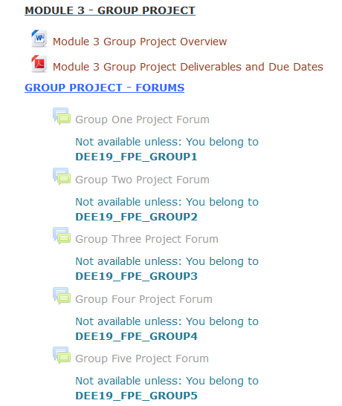

**3.5.3 Skype** will be used for group meetings. Please insist that the group has a Skype meeting *at leas*t at the beginning of each segment, and ask the group leader to email you a very brief summary stating:

- Who attended

- Apologies

- Absent without apology

-What was decided (*who* is to do *what*).

Individuals not attending will simply have work allocated to them by the rest of the group.

You may, at your discretion, also allocate a Blackboard room for each group. Despite the group’s ability to record their meetings, it is still advisable to insist on written minutes.

**3.5.4 DropBox** will be used to share documents (work-in-progress) between the group members. The group leader for Segment 1 can be asked to create a shared DropBox, and invite all group members as well as yourself and the responsible lecturer.

##### 3.6 Final Presentation

You will have to assist the groups with their final presentation via Blackboard. Here is an [example of an email](http://eitdata.info/fpe/FPE_Email_Group_Presentation.docx) you can send out.

##### 3.7 Project Submission

You need to create a submission box in Moodle for each group. This is done as follows:

1. In the FPE module section on Moodle click Add an Activity or Resources and then select Assignment > Add.
2. Name the submission box *Group Project Segment 1 - Due [date], Group Project Segment 2 - Due [date] etc and so on.*
3. Click Expand all to view all the settings.
4. Set the due date
5. Scroll down to Group Submission Settings, and to “Students Submit in Groups” change this to Yes. All other settings are unchanged.
6. Click Save and Return to course and repeat for other segments.

This will show up as follows on Moodle:

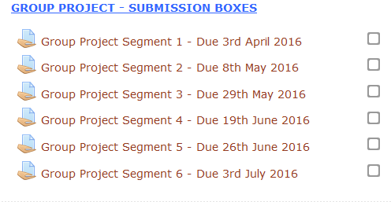

Every group member will be able to submit however we will allocate this responsibility to the group leader. Once the submission has been uploaded all group members will be able to view and edit the submission if needed. The assessor only needs to grade one member of the group (perhaps the group leader) and the grade will apply to all members.

***3.5 Project Timetable and deliverables***

The project will run according to the following schedule, but it could start a week or two earlier. It all depends on when the theoretical part starts.

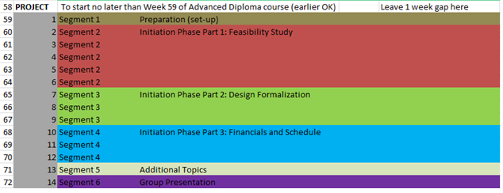

There are two documents to consider.

The first one is simply an [example of a marked-up calendar](http://eitdata.info/fpe/FPE_Example_Marked_up_Calendar.pdf). You can create your own and distribute it amongst the group.

The second document is a [summary of project deliverables and due dates.](http://eitdata.info/fpe/FPE_Project_Deliverables_and_Due_Dates.docx) You can edit it and distribute it amongst the group.

Also consider the possibility of using Google Calendar. Keep in mind that not all group members will be Google users. Confirm with all group members that they can actually see the project calendar.

END OF OVERVIEW