|  |  |  |  |
| --- | --- | --- | --- |
| Advanced Diploma of XXX  (COURSE CODE) | | | |
|  | | Overview for Students | |
|  | |
| Fundamentals of Professional Engineering | |
|  |  |
|  | V1.4 |
|  | |  |  |
|  | |  |  |
|  | |  |  |
| |  |  |  |  | | --- | --- | --- | --- | | Created By: | Deon Reynders | Date: | 29/08/15 | | Reviewed By: |  | Date: |  | | | | |
|  |  |  |  |
|  |  |  |  |
|  | | | |
|  | | | |



FPE Overview for Students

1. Introduction

The following is a very brief overview of the FPE module.

Originally the module was scheduled to run somewhere in the beginning of the Advanced Diploma courses, typically as Module 3, 5 or 7. This meant that both the theoretical and project components would stretch over roughly a year.

For various administrative reasons (and because it is easier to remain motivated over a shorter time period) it was decided to move both components into the last six months of the course. The exact timing will differ between Advanced Diploma courses and will be communicated to you by your course co-ordinator.

In newly-accredited or-reaccredited courses the FPE module will be in the correct position. In ‘older’ courses (where it is listed as Module 3, 5 or 7) it will be moved as per the previous paragraph.

1. Theoretical Component

##### Webinars

The topics, as listed in the older course brochures, have been condensed as follows:

**WEBINAR 1**

Topic 1A Time Management

Topic 1B Portfolio of Skills

Topic 1C Communication Skills

Topic 1D Decision Making

-----------------------------------------------------------------------------

**WEBINAR 2**

Topic 2A Project Management: Work Breakdown Structures

Topic 2B Project Management: Scheduling

Topic 2C Project Management: Qualitative Risk Analysis

Topic 2D Project Management: Quantitative Risk Analysis

-----------------------------------------------------------------------------

**WEBINAR 3**

Topic 3A Project Costing and Cash Flow Modelling

Topic 3B Discounted Cash Flow

-----------------------------------------------------------------------------

**WEBINAR 4**

Topic 4A Technical Writing and Specifications

Topic 4B Group Dynamics

Topic 4C Leadership and Professional Conduct

Topic 4B Ethics in Engineering

------------------------------------------------------------------------------

**WEBINAR 5**

Topic 5A Responsibilities of the Engineering Associate

Topic 5B Engineering Standards and Codes of Practice

Topic 5C Global and Environmental Issues

Topic 5D Sustainable Engineering

-----------------------------------------------------------------------------

**WEBINAR 6**

Topic 6A Workplace Health & Safety Issues

Topic 6B Presentation Skills

Topic 6C Technical Skills and Career Planning

Topic 6D Contract Law

------------------------------------------------------------------------------

The first four webinars will be presented over four consecutive weeks, whereas webinars 5 and 6 will be released for asynchronous online viewing afterwards. The screenshot below shows a *typical* schedule, but it needs to be repeated that this will differ from course to course.

‘Week’ refers to the specific week (1 thru 72) of an Advanced Diploma course.

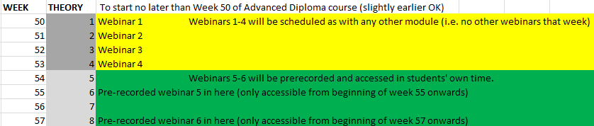

##### 2.2 Assignment

There is a single (substantial) assignment to be completed individually. This will be made available via Moodle in the usual way and you will be given ample time for completion. There is a very strong mapping between the assignment and the group project following it; it is essential that you master the basic project-related concepts before embarking on the group project.

1. Group Project

The second part of the FPE module consists of a group project. This is a critical component In terms of the Engineers Australia accreditation.

##### Project Overview

For the ‘big picture’ please refer to the [FPE Project Overview](http://eitdata.info/fpe/FPE_Project_Overview.docx) (press Ctrl and click on the link). To make the project work more manageable, it has been divided into six chunks or ‘segments’, each culminating in a submission to be uploaded to Moodle by a given date.

Each submission is to be submitted on a template. You will find the links to these in Section 3.3 of the Project Overview.

Liberal use is made of help files, which can be accessed via hyperlinks. This approach facilitates more uncluttered templates and also allows for the help files to be updated easily, based on feedback from lecturers and students.

##### Group Allocation

The Advanced Diploma cohorts will be divided into groups of approximately 10 students. Where possible, EIT will endeavour to keep groups more or less in the time zone, but please understand that, due to the global distribution of course participants, this is not always possible.

##### 3.3 Group Communication

The group members will communicate via email, Skype, Moodle Forums, and DropBox. Refer to section 2.3 of the Project Overview for more details. You will also receive guidance from your course co-ordinator in this regard.

IT IS OF THE UTMOST IMPORTANCE THAT YOU USE THE BEST POSSIBLE EMAIL ADDRESS FOR THE PROJECT. PLEASE DO NOT USE A ‘DISPOSABLE’ EMAIL ACCOUNT THAT YOU ONLY ACCESS ONCE IN A BLUE MOON.

##### 3.4 Project Timetable and deliverables

The project will run according to the following schedule, but it could start a week or two earlier, depending on the scheduling of the preceding module. Some of the preliminary work (e.g. setting up of accounts, etc.), could even be done few weeks in advance, but you will be kept informed by your co-ordinator.

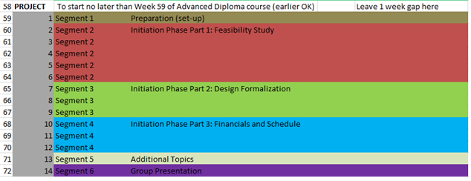

A detailed schedule with deadlines for deliverables will be given to you when the project commences.

For the purpose of sharing documents between the group members and EIT staff, and for interim submissions, folders for the project deliverables will be created in DropBox.

For the final submission in Week 72, submission boxes will be created in Moodle.

It is not necessary for the whole group to submit; only the group leader at any given point in time needs to do so.

END OF OVERVIEW