Fundamentals of

Professional Engineering

(FPE)

**Group Project Overview**

Ver3.2

***ITH MODEL ANSWERS***



1. **INTRODUCTION**

This document provides an overview of the FPE project component, and is intended as a support document for participating students. The project will cover a simple lighting system for isolated rural communities.

For any queries email your course co-ordinator.

**At first glance this project may seem like a formidable exercise, but keep in mind that:**

**(a) it will be spread over 14 weeks**

**(b) it is a collaborative effort, and**

**(c) all documentation will be developed on templates.**

All terminology used will be as per the Project Management Body of Knowledge or PMBOK (generally pronounced as “pim-bok”). See Annexure 1 for more details on PMBOK. The PMBOK guide is normally for sale as a hard copy, but if you spend some time online you will find downloadable PDF copies.

1. **PROBLEM DEFINITION**

Please document any assumptions you have to make.

Each group represents a small R&D company.

You have been asked to come up with a lighting system for use in remote areas where villagers have no access to electricity. The goal is to replace paraffin (kerosene) lamps and allow villagers to perform activities such as reading and sewing at night. Domestic appliances will not be supported.

Yours will be a pilot project.

Your solution should allow at least 4 hours’ operation of one high-efficiency lamp per household per night.

The maximum number of dwellings per village will be fifteen.

Once the installation has been completed, the villagers will perform their own first-line maintenance.

You may select a site anywhere in the world, provided there is sufficient sunlight, wind or water available, depending on the type of renewable energy you wish to use. The choice of location is all yours, but you need to supply the exact latitude and longitude and prove via Google earth that you are not in the middle of a lake, on top of a mountain, or right in the middle of a city! It will be advantageous, though, if some of the group members are personally familiar with the geography, culture, systems of governance, etc.

The funding will be provided by a private donor, hence it is important to show that funds are spent judiciously. This is a not-for-profit exercise.

Because of the remoteness of the proposed installation it must be relatively easy to transport, set up and maintain the hardware, and you must address the spares and maintenance issues in your proposal.

***In real life the complete project might run over, say, two years. It would include the actual development, installation and commissioning of the lighting systems, including training in first line maintenance and provision of spares. However, for your ‘FPE project’ (over the 14 weeks) you will only do the planning for the project.***

1. **HOW WE ARE GOING TO APPROACH THE PROJECT**
   1. **Manpower**

We are scheduling the project to commence at around week 50 of your Advanced Diploma course. At this point the attrition rate is very small. In addition, we will place 8-10 students in each group.

***The idea is that we share the workload, which reduces the individual workload dramatically.***

**3.2 Collaboration**

Once the groups have been formed (you will receive the relevant information via your course coordinator) they will communicate as follows:

* [Group calls via Skype](http://eitdata.info/fpe/FPE_Setup_Help_Skype.docx)
* [File sharing via DropBox](http://eitdata.info/fpe/FPE_Setup_Help_DropBox.docx)
* [Group text communication via Moodle Forums](http://eitdata.info/fpe/FPE_Setup_Help_Moodle.docx)

In this way we will have a proper ‘paper trail’, and EIT staff will be able to monitor progress.

***Please minimize group interaction via email, as this makes it very difficult for us at EIT to monitor the group’s activities.***

**3.3 Monitoring**

It is of critical importance that every group member participates. This is an Engineers Australia requirement. In a perfect world one would prefer not to ‘police’ the process, but as we proceed we will not only check individual participation, but we will also require declarations by individuals and/or group leaders. We simply cannot afford freeloaders, and we trust that you will understand.

If personal circumstances make it difficult or impossible to participate, you need to contact your course coordinator immediately.

To make progress monitoring easier we will also break the work into chunks or ‘segments’ with a duration of one to five weeks.

**3.4 Templates**

There are many project templates available online. However, to simplify things we will use our own. You can get them here:

* [Segment 1 Template](http://eitdata.info/fpe/FPE_Project_Template_Segment_1.docx)
* [Segment 2 Template](http://eitdata.info/fpe/FPE_Project_Template_Segment_2.docx)
* [Segment 3 Template](http://eitdata.info/fpe/FPE_Project_Template_Segment_3.docx)
* [Segment 4 Template](http://eitdata.info/fpe/FPE_Project_Template_Segment_4.docx)
* [Segment 5 Template](http://eitdata.info/fpe/FPE_Project_Template_Segment_5.docx)
* [Segment 6 template](http://eitdata.info/fpe/FPE_Project_Template_Segment_6.docx)

See 3.6 for an explanation of ‘segments’.

**3.5 Final Submissions**

We will create submission folders on Moodle. Only the group leaders need to submit the final documents for each segment.

**3.6 Sharing of Work-in-Progress**

While busy collaborating on a specific segment (and before the final document is ready to be submitted on Moodle), groups will share source documents (i.e. personal contributions, sections to be proofread, etc.) with each other via DropBox. Go [here](http://eitdata.info/fpe/FPE_Setup_Help_DropBox.docx) for more information.

**3.7 Segments**

To simplify things and make the project more manageable, we had to break the project up in ‘chunks’. Because the word ‘phases’ would be apt, but has another meaning in Project Management, we opted for ‘segments’.

The segments are as follows:

* Segment 1: Getting the group going, and deciding on a location for the project
* Segment 2: Initiation Phase part 1: Feasibility Study
* Segment 3: Initiation Phase Part 2: Formalized Design and Extent of Work
* Segment 4: Initiation Phase Part 3: Financials and Schedule
* Segment 5: Additional topics
* Segment 6: Group Presentation

**3.8 Scheduling**

Because the dates differ for each cohort, we will publish the schedules separately. However, the project will start around week 50 of your studies. The allocated times are as follows:

* Segment 1: 1 Week
* Segment 2: 5 Weeks
* Segment 3: 3 Weeks
* Segment 4: 3 weeks
* Segment 5: 1 week
* Segment 6: 1 week

EIT will not police the week-on-week progress, but groups will need to ensure that projects stay on track, else the group members will not be able to graduate at the end of the 72 weeks.

**3.9 Detailed description of segments**

In short; here is what the student groups will produce over the 3-month period:

* Project Study
  + Problem Definition
  + Contextual Analysis
  + Requirements Analysis (Functional Specification)
  + Alternative Solutions
  + Analysis of Alternatives (selection of best option)
  + Risk Analysis
* Detailed System Specification (of the proposed solution)
* Work Breakdown Structure
* Project Scope
* Project Budget
* Project network diagram (PERT)
* Project schedule (Gantt )
* Discussion
* Presentation

The following is the detailed project execution plan.

**3.9.1 Segment 1: Preparation**

**Duration: 1 week**

**Output:** Group decision on community to be serviced.

**Note:** Use the template identified in 3.3.

* Group operational and able to communicate via Moodle forums
* All group members have read this document
* Skype group set up for live meetings
* DropBox accounts set up for sharing project files
* First group leader selected
* Decision made (by group) on the location of the community to be serviced
* Project Charter written

**3.9.2 Segment 2: Initiation Phase Part 1**

**Duration: 5 weeks**

**Output**: Feasibility Study.

**Note:** Use the template identified in 3.3.

* Problem Definition
* Contextual Analysis
* Requirements Analysis (Functional Specification)
* Alternative Solutions
* Analysis of Alternatives (selection of preferred solution)
* Risk Analysis

**3.9.3 Segment 3: Initiation Phase Part 2**

**Duration: 3 weeks**

**Output:** Formalized Design and Extent of Work  
**Note:** Use the template identified in 3.3.

* Detailed System Specification (Proposed Solution)
* Work Breakdown Structure
* Project Scope

**3.9.4 Segment 4: Initiation Phase Part 3**

**Duration: 3 weeks**

**Output:** Financials and Schedule

**Note:** Use the template identified in 3.3.

* Project Budget
* Network Diagram PERT
* Schedule (Gantt

**3.9.5 Segment 5: Additional topics**

**Duration: 1 week**

**Output:** Discussion of these topics in relation to project  
**Note:** Use the template identified in 3.3.

* Project Cash Flow
* Leadership and Professional Conduct
* Ethics in Engineering
* Responsibilities of the Engineering Associate
* Engineering Standards and Codes of Practice
* Global and Environmental Issues
* Sustainable Engineering
* Health and Safety Issues

**3.9.6 Segment 6: Presentation**

**Duration: 1 week**

**Output:** Live group presentation (PowerPoint)

**ANNEXURE 1**

**BACKGROUND READING**

1. **REFERENCE DOCUMENTS**

Ideally all students should have copies of ‘A Guide to the Project Management Body of Knowledge (PMBOK® Guide) – Fifth Edition’ which, in printed format, costs around $60. You could, alternatively, Google it and find uploaded PDF copies. It’s all up to you.

There is a very helpful PMBOK-based guide from the Office of the Chief Information Officer, U.S. Department of Commerce, viz. ‘DOC Scalable Project Management Methodology’, at <http://goo.gl/Vl4QiY> .

In terms of the DOC classification (as in the document above)y our project would be a ‘Level 1’ project (<$5M), although we will not abide strictly by *their modus operandi* (see the table in section 5.3 ‘Deciding on the Elements of a Project Management Methodology’) as (a) that classification is an internal arrangement for the DOC, and (b) ours is a paper exercise and, in addition, a learning experience anyway.

You can also download a PowerPoint slideshow on the topic of the Project Plan (and its mapping to the PMBOK) by Will Brimberry, program manager at the Project Management Office of USGS (U.S. Geological Survey) here: <http://goo.gl/Mn4JJe> .

1. **PROJECT MANAGEMENT SUPPORT**

By default groups will use GanttProject for project management. We, at EIT, have nothing against the use of more sophisticated software such as MSProject, but then ALL group members need to have it installed on their computers.

1. **PM PROCESS GROUPS VS. PROJECT PHASES**

Now let’s look at some terminology. You will find more detail in the DOC article as well as the PMBOK guide.

**3.1 PMBOK Process Groups**

PMBOK defines the following ‘Process Groups’. Do not confuse these with ‘phases’ (see next section) as some of them could be present in several project phases. One phase can contain more than one process group and *vice versa.*

* Project Initiation
* Project Planning
* Project Execution
* Project Monitoring and Control
* Project Closeout

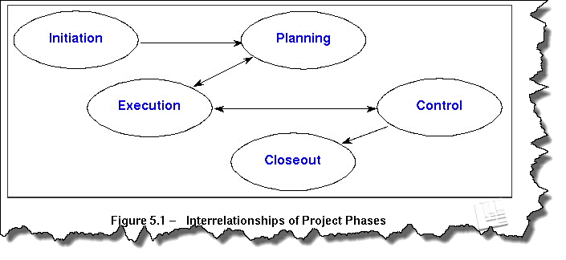

**3.2 Project Phases**

Here are some typical phases. Their use depends on the type of project and also the industry in which the project is being executed. You will be focusing primarily on those marked with asterisks.

* Concept development
* Prefeasibility
* Feasibility *
* Validation
* Planning *
* Product design
* Product prototyping
* Construction
* Implementation
* Testing
* Commissioning
* Handover
* Closure
* Disposal
* Environmental Rehabilitation

One or more of the Process Groups will be visited during each of these project phases. For a more detailed discussion on process groups and phases, see the PMBOK Guide or the DOC document mentioned earlier.

The following figure depicts the phases of a typical project.

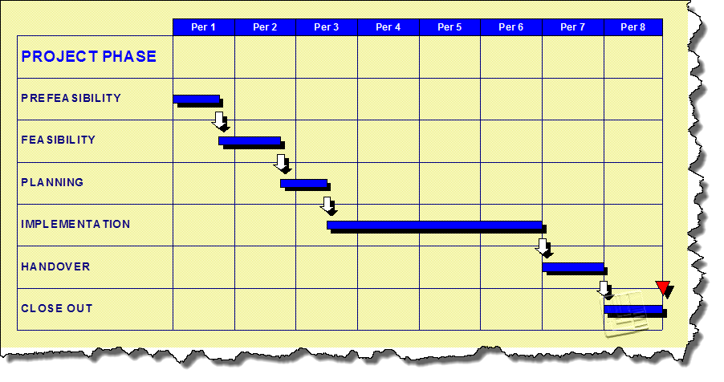

1. **PM ROLES**

Just for the record we are listing some relevant roles here. See section 6 of the DOC guide for more information.

* Project Management Office (PMO)
* Project Manager
* Project Management Team
  + Configuration Manager
  + Quality Manager
  + Risk Manager
  + Project Team Members
* Customer
* Stakeholders
* Project Sponsor

**5.0 THE PROJECT MANAGEMENT PROCESS GROUPS**

This section lists the various project-related documents and activities against the PMBOK process groups. Since we cannot actually implement our design, we will primarily focus on the project plan, and produce the documents marked with asterisks. The paragraph numbers line up exactly with those in the Dept. of Commerce (DOC) document, so you can refer to that for additional information.

Also, see this as a ‘master list’ from which we can pick and choose.

**5.1 INITIATING PROCESS GROUP**

5.1.1 Project Concept Document/Business case *

5.1.2 Project Feasibility Study *

5.1.3 Project Charter *

We will add a Stakeholder Management Plan here, because of possible ‘political sensitivities’. The PM Docs template for that can be found in the Initiation Phase folder on the PM Docs website (see section 4).

**5.2 PROJECT PLANNING PROCESS GROUP**

7.2.1 Kick-off meeting

* + 1. Integrated Management Control Plan *

5.2.2.1 Scope Management Plan *

5.2.2.2 Schedule (Time)Management Plan *

5.2.2.3 Cost (Budget) Management Plan *

5.2.2.4 Quality Management Plan *  
5.2.2.5 Procurement (and Contract) Management Plan *

5.2.2.6 Staffing (Human Resources) Management Plan *

5.2.2.7 Communication Management Plan *

5.2.2.8 Risk Management Plan *

5.2.2.9 Change Management Plan *

5.2.3 Project Scope Statement (Project Statement of Work)*

5.2.4 Work Breakdown Structure *

5.2.5 Organizational Breakdown Structure

5.2.6 Responsibility Assignment Matrix

5.2.7 (a) Project Schedule and Calendar *  
 (b) Project Schedule Network Diagrams (PERT, Gantt)*

5.2.8 Project Budget *

5.2.9 Performance Measurement Baseline

5.2.10 Earned Value Measurement

**5.3 PROJECT EXECUTION PROCESS GROUP**

5.3.1 Direct and Manage Project execution

5.3.2 Perform Quality Assurance

5.3.3 Acquire & Develop the Project Team

5.3.4 Information Distribution

5.3.5 Produce Procurement Documentation and Execute Procurement Actions

**5.4 PROJECT MONITORING AND CONTROLLING PROCESS GROUP**

5.4.1 Monitor and Control Project Work

5.4.2 Integrated Change Control

5.4.3 Perform Quality Control

5.4.4 Performance Reporting

5.4.5 Risk Monitoring and Control

5.4.6 Contract Administration

**5.5 CLOSING PROCESS GROUP**

5.5.1 Administrative Closure

5.5.2 Contract Closure

5.5.3 Documentation of Lessons Learned

5.5.4 Celebration of Project Success

**6.0 THE PROJECT PLAN**

The elements in Section 5 marked ‘*’ essentially comprise the Project Plan. Some people call this a ‘Project Quality Plan’ but it is a confusing name as it sounds almost the same as the Quality Management Plan. So let’s stick to ‘Project Plan’.

Let’s repeat those elements (the ones marked ‘*’) here for clarity.

* Business Case
* Project Feasibility Study
* Project Charter
* Scope Management Plan
* Schedule Management Plan
* Cost Management Plan
* Quality Management Plan
* Procurement Management Plan
* Human Resources Management Plan
* Communication Management Plan
* Risk Management Plan
* Change Management Plan
* Project Scope Statement
* Work Breakdown Structure
* Project Schedule and Calendar
* Project Schedule Network Diagrams
* Project Budget

How do they fit together? The slideshow by Will Brimberry gives a good overview as per the screenshot on the next page. By the way, do not get ‘carried away’ by all the acronyms in the PowerPoint presentation, as many of them pertain to the USGS.

You will notice that the screenshot on the next page shows only the Project Charter under the heading of Authorization, and not the Business Case or the Feasibility Study. The reason for that is as follows.

The first step in the project execution is the creation of the Business Case (“why should we consider doing this, and, if it’s worth doing for whatever reason then what alternatives do we have?”).

If this results in a decision to proceed (albeit with care), the Project Feasibility Study is done (“is this do-able at all?”).

If the answer is “yes”, then the contents of the Business Case and the Project Feasibility Study are combined to form the Project Charter, which is essentially a formal authorization to proceed with the project. Hence only the latter document forms part of the formal Project Plan.

Incidentally, the FPE project will focus on delivering some infrastructure for 3rd world (‘disadvantaged’) communities, hence it is primarily based on humanitarian considerations and not on profit. Consequently you might have to edit the outline of your Business Case document somewhat.

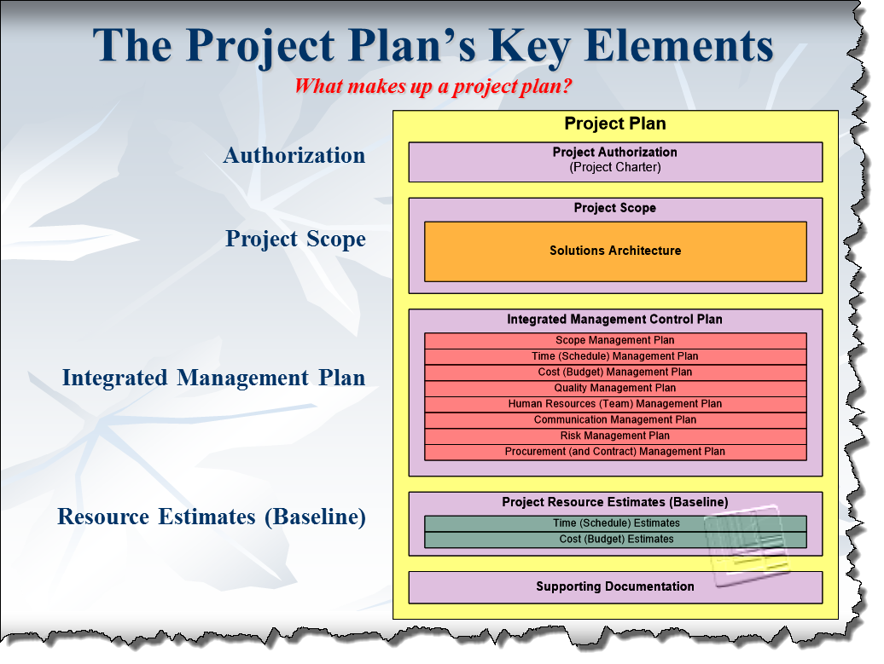

**NOTE: BECAUSE OF TIME CONSTRAINTS WE WILL NOT BE PRODUCING THE INTEGRATED MANAGEMENT PLAN.**

**It is, however, not a difficult process as the templates already exist.**